KWAME NKRUMAH UNIVERSITY OF SCIENCE AND TECHNOLOGY, KUMASI.
COLLEGE OF SCIENCE
FACULTY OF PHYSICAL AND COMPUTATIONAL SCIENCES
DEPARTMENT OF COMPUTER SCIENCE
PROJECT PROPOSAL


TITLE
DESIGN AND IMPLEMENTATION OF A MOBILE APPLICATION FOR AUTOMATED CHEST X-RAY IMAGE QUALITY ASSESSMENT AND ENHANCEMENT USING A HYBRID CLAHE-CNN MODEL

SUBMITTED BY:
SULEIMAN BABA MOHAMMED – 3381522
SURAIYA MOHAMMED – 3401022
SUBMITTED TO:
PROFESSOR FRIMPONG TWUM
CHAPTER ONE
PROJECT PROPOSAL
Project Topic
Design and Implementation of a Mobile Application for Automated Chest X-Ray Image Quality Assessment and Enhancement Using a Hybrid CLAHE-CNN Model.
Introduction and Background
Chest X-ray imaging remains one of the most relied-upon diagnostic tools for identifying respiratory conditions such as pneumonia, tuberculosis, and lung cancer, particularly in Ghana, where these diseases constitute a significant public health burden. However, a substantial proportion of X-ray images produced in Ghanaian healthcare facilities fall below the quality threshold required for confident diagnosis. Patient movement during exposure, poorly calibrated machines, aging equipment, and inconsistent power supply all contribute to images that are blurry, poorly contrasted, underexposed, or noisy.
When images are of poor quality, two outcomes typically follow: either the radiologist attempts a diagnosis on a substandard image and risks missing critical findings, or the patient is sent for a repeat scan, adding cost, delay, and additional radiation exposure. Research further shows that inter-observer variability is amplified when image quality is poor, meaning two radiologists reviewing the same substandard image may reach different conclusions about its diagnostic utility.
Existing deep learning solutions for image quality assessment and enhancement perform well in the literature but typically require GPU hardware and stable cloud connectivity, neither reliably available in most Ghanaian hospitals. Classical methods such as CLAHE are lightweight and work offline, but apply fixed rules regardless of image-specific characteristics and often fall short on severely degraded images.
This project proposes a practical middle ground: ClearScan, a hybrid system that combines CLAHE-based classical enhancement with a Convolutional Neural Network (CNN) trained on synthetically degraded X-ray pairs. The system performs automatic quality assessment and applies enhancement using either classical or CNN-based methods depending on connectivity, using objective metrics to determine and display the best result when multiple enhancement options are available.
Problem Statement
Poor chest X-ray quality is a persistent and measurable problem in Ghanaian healthcare. The WHO estimates that in low-resource settings, up to 30% of X-rays must be repeated due to quality failure, a figure that drives up radiation exposure, cost, and waiting times for patients who can least afford delays.
Manual quality review by radiologists is inconsistent, time-consuming, and subject to fatigue-related error. Fully AI-driven solutions while powerful remain out of reach for facilities operating on basic mobile devices without reliable internet connectivity. Meanwhile, classical image processing tools alone have demonstrated limited effectiveness on severely degraded medical images, particularly those affected by non-uniform contrast or complex noise patterns.
There is a clear, unmet need for a system that is automated and objective, but also practical enough to run without specialist infrastructure, and intelligent enough to select the most effective enhancement strategy for each individual image. This project directly addresses that gap by combining classical and learning-based methods within a single pipeline.
Aim of Project
The aim of this project is to design, implement, and evaluate ClearScan, a hybrid chest X-ray image quality assessment and enhancement system that integrates CLAHE-based classical image processing with a CNN-based enhancement model, running as an interactive mobile application on standard smartphones and tablets. The system adapts to connectivity: a CNN module handles quality assessment and enhancement when online, comparing its output against the classical pipeline using objective quality metrics to present the optimal result; offline, it falls back automatically to the CLAHE-based approach for both functions, ensuring uninterrupted operation regardless of connectivity.
Specific Objectives of the Project
- Compute five no-reference image quality metrics for each chest X-ray — Laplacian variance (sharpness), RMS contrast, Shannon entropy, histogram spread, and noise variance — to build an objective numerical profile of each image’s quality before any processing.
- Train a lightweight CNN-based classifier on labelled X-ray quality data to categorise each image as Good, Fair, or Poor, with defect-specific explanations (e.g., motion blur, underexposure, excessive noise), and compare its performance against a classical threshold-based baseline classifier.
- Implement a CLAHE-based classical enhancement pipeline, incorporating CLAHE (clip limit 2.0, tile size 8×8), Non-Local Means denoising, and unsharp masking, that is triggered automatically for images classified as Fair or Poor.
- Develop a CNN-based enhancement model (autoencoder architecture) trained on synthetically degraded X-ray pairs, capable of learning data-driven image correction as an alternative enhancement path.
- Build a metric-based comparison engine that evaluates CLAHE-enhanced and CNN-enhanced outputs using SSIM, PSNR, and BRISQUE scores, and automatically selects the superior result when both enhancement methods are available.
- Conduct a structured comparative evaluation of both enhancement approaches on 298 chest X-ray images manually labeled by the project team, targeting a mean quality improvement of at least 20% and classifier F1-score and ROC-AUC of no less than 0.85.
- Build the entire system — quality assessment, hybrid enhancement, comparison logic, and reporting — as an interactive mobile application.
Project Scope
The system focuses on grayscale chest X-ray images (512×512 to 1024×1024 pixels) within a mobile application environment. The scope includes:
- Automated image quality assessment using five no-reference metrics offline, supplemented by a CNN classifier online.
- Adaptive hybrid image enhancement — CLAHE-based on-device offline, CNN-based when online — with the processing method selected automatically by connectivity.
- Metric-based comparison and selection of enhancement outputs (SSIM, PSNR, BRISQUE) when both methods are available.
- An interactive mobile application supporting image upload, quality reporting, side-by-side comparison, and result export.
- Full offline functionality, with classical assessment and enhancement operating independently of internet access.

The system explicitly excludes:
- Colour images, fluoroscopy video, CT scans, MRI, or any modality other than grayscale X-ray.
- Integration with hospital Picture Archiving and Communication System (PACS) or electronic health record systems.
- Diagnostic interpretation — the system is a decision-support aid, not a replacement for radiologist judgement.
- Cloud deployment or multi-user server architectures.

Motivation for Undertaking the Project
Radiologists in Ghana frequently work with ageing equipment, under time pressure, and without quality assurance tools that clinicians elsewhere take for granted. Patients suspected of tuberculosis or pneumonia may wait longer because a poor scan must be repeated or, worse, receive a diagnosis based on a compromised image. The COVID-19 pandemic only deepened the strain on already stretched radiology departments.
What motivated this project is not only the problem it addresses, but the specific way it addresses it. Classical image processing is fast, transparent, and runs on hardware already present in most facilities. But preliminary work revealed a critical limitation: classical methods alone do not perform well enough on severely degraded images, particularly those with non-uniform noise or extreme underexposure. That observation is precisely what makes the hybrid approach necessary and original.
By training a CNN enhancement model on synthetically degraded X-ray pairs — bypassing the need for scarce paired clinical data — and combining it with CLAHE-based processing under a metric-driven selection framework, this project proposes an approach that is simultaneously research-grounded and practically deployable.
Justification of the Project
The case for this project rests on four points. Clinically, research shows that image quality improvements of this kind can improve diagnostic accuracy by 15–20% — a meaningful gain where tuberculosis and pneumonia are major killers — and the hybrid approach's per-image selection of the best enhancement further reduces the risk of artefacts from an inappropriate correction. Academically, most existing studies evaluate classical or deep learning enhancement in isolation; this project contributes a comparative, metric-driven selection framework integrating both within a single deployable system, an approach not well-represented in undergraduate-level literature, while the synthetic degradation training strategy offers a practical workaround to the paired-dataset problem limiting CNN-based enhancement research. Financially, each repeated chest X-ray in Ghana costs GHS 100–400, so even a modest reduction in the current ~30% repeat rate yields meaningful savings for resource-constrained facilities, while also avoiding unnecessary radiation exposure, particularly for children and pregnant women. Strategically, the project directly supports Ghana's national health strategy and WHO goals for accessible quality diagnostics in underserved areas.
Project Methodology
System Overview
The system is built as a six-stage hybrid processing pipeline. Each stage is clearly defined, independently testable, and contributes either to the research evaluation or the deployable product or both.

Stage 1 - Preprocessing
Input images are loaded, resized to a maximum of 1024×1024 pixels, and normalised to ensure consistent metric behaviour across different image sources, equipment types, and acquisition conditions.
Stage 2 - Quality Assessment
Quality assessment operates in the two connectivity-dependent modes described in the Aim of Project - CNN-based when online, threshold-based when offline::
- No-reference metric computation: Five classical metrics are extracted — Laplacian variance (sharpness), RMS contrast, Shannon entropy (information content), histogram spread, and noise variance from smooth image regions. These provide an objective numerical profile of each image.
- CNN-based classifier: A lightweight convolutional network trained on labelled quality data predicts whether the image is Good, Fair, or Poor, with defect-specific explanations. A classical threshold-based classifier is implemented as a baseline for comparison. The CNN classifier’s advantage lies in its ability to recognise complex, non-linear degradation patterns that fixed rules cannot reliably detect.
Stage 3 - Dual Enhancement
Images classified as Fair or Poor are processed using an adaptive enhancement strategy based on system mode:
Offline Mode - CLAHE-Based Enhancement: Images are processed with CLAHE (clip limit 2.0, tile size 8×8) for contrast correction, followed by Non-Local Means denoising for noise reduction, and unsharp masking (sigma 1.0, amount 1.5) for edge sharpening.
Online Mode - CNN-Based Enhancement: An autoencoder model trained on synthetically degraded X-ray pairs performs learned image correction, adapting to image-specific degradation patterns.
Optional Dual Processing (Online Only): When computational resources allow, both CLAHE and CNN enhancement may be applied, and the best result is selected using objective quality metrics.
Stage 4 - Metric-Based Comparison and Selection
When both enhancement methods are applied (in online mode), the outputs are evaluated using SSIM (Structural Similarity Index), PSNR (Peak Signal-to-Noise Ratio), and BRISQUE (Blind/Referenceless Image Spatial Quality Evaluator). The result with the superior composite score is automatically selected as the primary output presented to the user. In research mode, all three outputs (original, CLAHE-enhanced, CNN-enhanced) and their metric scores are displayed for analysis.
Stage 5 - Comparative Evaluation (Research Contribution)
A structured evaluation is conducted on 298 chest X-ray images manually labeled by the project team using established radiographic quality criteria, with independent validation of the good quality images by a medical doctor (70/15/15 train/validation/test split). Evaluation targets:
- CNN classifier: F1-score >= 0.85, ROC-AUC >= 0.85, assessed via confusion matrix and ROC curves.
- Enhancement comparison: Mean quality improvement of >= 20% across affected images, with per-class (Good/Fair/Poor) breakdowns and statistical significance testing.
- Method comparison: Head-to-head SSIM, PSNR, and BRISQUE scores for CLAHE-only vs CNN-only vs hybrid selection.
Stage 6 - Mobile Application and Packaging
The entire pipeline is implemented as a mobile application, allowing radiographers to upload chest X-ray images through the app interface and benefit from the adaptive online/offline processing described earlier. The backend processes the image, computes quality metrics, and generates enhanced outputs, while the mobile frontend displays the original and enhanced images side-by-side with quality scores and defect explanations, allowing users to interactively review results and export processed images and reports. The system is designed to be lightweight and responsive, targeting an average per-image processing time under 3 seconds on standard smartphones and tablets, with no additional software installation required beyond the application itself.
Development Stack
The system uses Python 3.10 with TensorFlow/PyTorch, OpenCV, NumPy, SciPy, scikit-image, scikit-learn, Matplotlib, and BRISQUE-py for image processing and ML, deployed as a mobile application with a Flutter frontend and FastAPI backend supporting the adaptive online/offline architecture described above. Version control is managed via GitHub.
Project Deliverables
- Backend source code — modular, documented, and hosted on GitHub — implementing the complete hybrid pipeline: preprocessing, quality assessment (metrics + CNN classifier), CLAHE enhancement, CNN-based enhancement, and the metric comparison engine, exposed via REST APIs.
- Frontend mobile application source code — built with Flutter — providing an intuitive interface for image upload, visualisation of results, side-by-side comparison of outputs, and display of quality metrics and explanations. When online, the CNN module is used for both quality checking and enhancement; when offline, the classical CLAHE-based pipeline handles both functions automatically.
- Trained deep learning models — including the CNN quality classifier and autoencoder-based enhancement model — along with training scripts, configuration files, and the synthetic degradation pipeline used for dataset generation.
- Deployed mobile application — installable on Android and iOS devices, enabling radiographers to capture or upload X-ray images, view quality assessments, preview enhancements, and export results. When internet is available, the CNN module drives both quality checking and enhancement; when offline, the classical CLAHE-based pipeline handles both functions to ensure continuous operation.
- Technical project report — detailing system architecture, methodology, experimental setup, comparative evaluation results, validation metrics, and conclusions on the performance of classical versus CNN-based enhancement methods.
- Final project presentation — summarising the system design, implementation, key findings from the comparative study, and recommendations for adoption in Ghanaian healthcare settings.

Project Plan and Timelines
Action Plan
# | Phase | Description | Duration | Start Week | End Week
1 | Research & Planning | Literature review, problem definition, requirements gathering, and system objectives | 2 Weeks | Week 1 | Week 2
2 | System Design | Design system architecture, mobile app workflow, and define ML pipeline components | 2 Weeks | Week 3 | Week 4
3 | Data Acquisition & Preprocessing | Collect X-ray datasets, perform cleaning, resizing, normalization and synthetic degradation | 2 Weeks | Week 5 | Week 6
4 | Model Development | Develop and train CNN models for image quality assessment and enhancement | 3 Weeks | Week 7 | Week 9
5 | Classical Processing Module | Implement CLAHE-based enhancement and quality metric computation for offline mode | 2 Weeks | Week 10 | Week 11
6 | Mobile Application Development | Build mobile app interface and integrate backend processing modules | 2 Weeks | Week 12 | Week 13
7 | System Integration & Testing | Integrate all modules, perform system testing, optimization, and validation | 1 Week | Week 14 | Week 14
8 | Documentation & Final Submission | Prepare report, presentation, and final project submission | 1 Week | Week 15 | Week 15
Table 1: Action plan

Work Breakdown Structure (WBS)
WBS ID | Work Package / Task
1.0 | Project Initiation & Planning
1.1 | Literature review on image enhancement and ML methods
1.2 | Problem definition and requirement analysis
1.3 | System architecture design
2.0 | Data Preparation
2.1 | Dataset collection (NIH ChestX-ray14, JSRT, Montgomery County)
2.2 | Data preprocessing and normalization
2.3 | Synthetic data generation for CNN training pairs
3.0 | Model Development
3.1 | CNN quality assessment model (Good / Fair / Poor classifier)
3.2 | CNN enhancement model (autoencoder architecture)
3.3 | Model training and evaluation
4.0 | System Development
4.1 | CLAHE-based enhancement module
4.2 | Quality metric computation module
4.3 | Backend development and API integration (FastAPI / Flask)
4.4 | Mobile application development (Flutter — Android & iOS)
5.0 | Integration and Testing
5.1 | System integration (online CNN mode + offline CLAHE mode)
5.2 | Performance testing and optimization
5.3 | User interface testing
6.0 | Deployment and Documentation
6.1 | Application deployment (Android / iOS)
6.2 | Report writing and documentation
6.3 | Final presentation preparation
Table 2: Work Breakdown Structure (WBS)

Gantt Chart
Activity | W1 | W2 | W3 | W4 | W5 | W6 | W7 | W8 | W9 | W10 | W11 | W12 | W13 | W14 | W15
Literature Review & Requirements | ■ | ■
System Design & Architecture |  |  | ■ | ■
Data Acquisition & Preprocessing |  |  |  |  | ■ | ■
Quality Metric Implementation |  |  |  | ■ | ■ | ■ | ■
CNN Quality Classifier Training |  |  |  |  | ■ | ■ | ■ | ■
CLAHE Enhancement Module |  |  |  |  | ■ | ■ | ■
CNN Enhancement Module |  |  |  |  |  |  | ■ | ■ | ■ | ■
Comparative Evaluation Engine |  |  |  |  |  |  |  | ■ | ■ | ■
GUI & System Integration |  |  |  |  |  |  |  |  | ■ | ■ | ■ | ■
Validation & Testing |  |  |  |  |  |  |  |  |  |  | ■ | ■ | ■
Report Writing & Submission |  |  |  |  |  |  |  |  |  |  |  | ■ | ■ | ■ | ■
Table3: Gantt Chart

Milestones — Major Targets and Achievements
Week | Major Target / Achievement
Week 2 | Development environment set up; dataset access confirmed; synthetic degradation pipeline operational.
Week 5 | All five no-reference quality metrics implemented and validated on test images. CNN classifier training commenced.
Week 7 | CNN-based quality classifier achieving F1-score >= 85% on the 298-image labelled subset.
Week 9 | Both enhancement pipelines (CLAHE-based and CNN autoencoder) operational with pre/post metric comparison.
Week 11 | Comparative evaluation complete — quantitative results (SSIM, PSNR, BRISQUE) showing best-performing method per image class.
Week 12 | Mobile application deployed; full hybrid pipeline integrated and running.
Week 15 | Technical report submitted and GitHub repository published with full source, documentation, and dataset annotations.
Table 4: Major Targets and Achievements

CHAPTER 2
REVIEW OF RELATED SYSTEMS
INTRODUCTION
This chapter reviews existing systems related to automated chest X-ray image quality assessment and enhancement. Current technologies, methods, and tools used in similar platforms are examined to identify their strengths, limitations, and gaps. These insights will inform the design and development of the proposed hybrid CLAHE-CNN mobile application for automated chest X-ray image quality assessment and enhancement in Ghanaian healthcare settings.
OVERVIEW OF EXISTING SYSTEMS
The challenge of ensuring chest X-ray image quality in clinical settings has driven significant research and commercial investment over the past decade. Traditional methods of quality assurance, which relied entirely on manual inspection by radiographers and radiologists, have proven insufficient given the growing volume of imaging studies, the documented variability in human judgement under fatigue, and the particular difficulties faced by healthcare facilities in sub-Saharan Africa where trained radiologists are scarce (Murphy et al., 2020).
Deep learning-based solutions — particularly Convolutional Neural Networks (CNNs) trained on large annotated datasets such as the NIH ChestX-ray14 dataset, which contains over 112,120 frontal-view chest X-ray images from 30,805 unique patients — have demonstrated the ability to assess and classify X-ray images at or above the accuracy of experienced radiologists (Rajpurkar et al., 2017; Wang et al., 2017). However, these solutions are predominantly designed for high-resource environments with reliable internet connectivity and GPU-powered infrastructure.
On the other side of the spectrum, classical image processing methods such as Contrast Limited Adaptive Histogram Equalization (CLAHE) are computationally lightweight and can operate entirely offline, making them well-suited to resource-constrained environments. CLAHE improves local image contrast by operating on small, non-overlapping sub-regions (tiles) of the image, avoiding the over-amplification of contrast that plagues standard histogram equalization (Reza, 2004). Studies have confirmed that CLAHE-processed medical images significantly improve the detection of edges and pathological features, enhancing classification accuracy when combined with machine learning models (Al-Dhabyani et al., 2022).
Despite these advancements, many existing systems operate in isolation — focusing on a single approach such as cloud-based deep learning or classical enhancement — rather than integrating multiple technologies into an adaptive, offline-capable solution. This lack of integration, particularly the absence of integrated quality assessment before enhancement and the absence of mobile deployment, highlights the need for a more comprehensive system.

REVIEW OF EXISTING SYSTEMS
A. CheXNet (Stanford Machine Learning Group, 2017)
The architecture employs a DenseNet-121 backbone with batch normalisation and produces class activation maps (CAMs) that localise the regions most predictive of each pathology, offering visual explainability. CheXNet was among the first systems to demonstrate radiologist-level performance on a multi-label chest X-ray task using a public dataset, accelerating subsequent research in AI-assisted radiology.
Features Include:
- Multi-label classification of 14 thoracic pathologies from a single frontal chest X-ray image.
- Class activation maps (CAMs) for visual localisation of pathology predictions.
- DenseNet-121 backbone with batch normalisation, trained on over 112,120 chest X-ray images.
- Benchmarked performance against four practising radiologists with documented F1 scores.
Good Features of the System (CheXNet)
1. Radiologist-level diagnostic performance: trained on 112,120 images from 30,805 patients, CheXNet matched or exceeded the diagnostic accuracy of practising radiologists on pneumonia detection (Rajpurkar et al., 2017).
2. Multi-label pathology detection: the system simultaneously classifies 14 thoracic conditions including atelectasis, cardiomegaly, pneumothorax, effusion, and consolidation — from a single frontal X-ray.
3. Visual explainability via CAMs: class activation maps highlight the regions driving each classification decision, supporting radiologist oversight, while the public release of methodology and benchmarks on NIH ChestX-ray14 enabled reproducibility and drove subsequent research..
Limitations of the System (CheXNet)
1. No image quality assessment or enhancement: CheXNet does not assess input image quality or attempt enhancement before classification, so poor-quality X-rays cause silent misclassification with no warning to the clinician.
2. Requires cloud infrastructure with no offline fallback: the system depends on GPU-powered cloud servers and has no mechanism for operation during the connectivity outages common in sub-Saharan African healthcare settings.
3. Not designed for mobile deployment, with weak training label noise: CheXNet's GPU-dependent architecture precludes deployment on smartphones at the point of care, and its NIH ChestX-ray14 training labels — generated via NLP on radiology reports rather than direct annotation — introduce noise that limits model performance (Oakden-Rayner, 2017).
B. CAD4TB (Delft Imaging Systems / Thirona, 2018–2024)
CAD4TB is designed specifically for low-resource, high-burden tuberculosis settings, supporting hybrid offline operation by performing analysis locally on a dedicated hardware box and synchronising to a central server once connectivity is restored (Stop TB Partnership, 2021). By 2024 it had been deployed in over 50 countries and was cited in WHO digital health guidance for TB elimination.
Features Include:
- Automated TB abnormality scoring from 0 to 100 based on deep learning analysis of lung regions.
- Abnormality heatmap overlay on the original chest X-ray, visualising the most affected lung regions.
- Offline-capable operation via a dedicated hardware box with automatic server synchronisation.
- PACS-compatible architecture integrating with standard digital radiography workflows.
Good Features of the System (CAD4TB)
1. Purpose-built for low-resource deployment: CAD4TB is explicitly designed for high-burden, low-income healthcare settings, including sub-Saharan Africa, where radiologists and specialist infrastructure are scarce.
2. Hybrid offline and online operation: the system runs locally on a dedicated offline hardware box and synchronises to a central server when connectivity is available, directly addressing the offline challenge in resource-constrained settings (Stop TB Partnership, 2021).
3. Widely validated with actionable visual output: evaluated across 18 independent studies and national TB prevalence surveys (Gelaw et al., 2023), CAD4TB also overlays an abnormality heatmap on the X-ray and integrates with standard PACS radiography workflows.
Limitations of the System (CAD4TB)
1. Narrowly scoped, with no quality assessment: CAD4TB is designed exclusively for tuberculosis abnormality scoring, performing no general quality assessment, enhancement, or detection of other pathologies, and consistently underperforms in patients aged 55+, those with prior TB, or HIV co-infection (Gelaw et al., 2023).
2. High cost and no mobile interface: the hardware box costs approximately USD 15,500 per unit (Stop TB Partnership, 2021), and operates only as a fixed desktop/hardware box with no mobile application for point-of-care use.
- No integrated image enhancement: poor-quality X-rays from patient motion, underexposure, or equipment degradation are processed without correction, potentially producing unreliable scores.
C. Lunit INSIGHT CXR (Lunit Inc., 2020–2025)
A 2023 multicentre evaluation against 226 radiologists achieved an AUC of 0.94, sensitivity of 0.90, and specificity of 0.89 (Vasilev et al., 2023), while a subsequent prospective real-world evaluation at Changi General Hospital found an AUC of 0.91 and reduced radiologist reading workload by 36.2% while maintaining 95% sensitivity for urgent cases (Sridharan et al., 2024).
Features Include:
- Detection of ten major thoracic abnormalities plus tuberculosis screening in a single AI tool.
- Worklist prioritisation and normal case filtering integrated into existing PACS and RIS workflows.
- Privacy-preserving local DICOM Gateway that strips patient-identifying data before cloud transmission.
- CE marking under EU MDR 2017/745 with regulatory clearances in Canada, Australia, Saudi Arabia, and other countries.
Good Features of the System (Lunit INSIGHT CXR)
1. Comprehensive multi-finding detection: the system detects ten major thoracic abnormalities plus TB screening in one tool, a far broader clinical scope than single-disease systems such as CAD4TB.
2. Clinically validated at scale with regulatory clearance: evaluated across multiple countries with prospective AUC of 0.91 and significant radiologist workload reduction (Sridharan et al., 2024), the system holds CE marking under EU MDR 2017/745 plus clearances in Canada, Australia, and several other countries.
3. Privacy-preserving workflow integration: a local DICOM Gateway strips patient data before AI transmission, while integration with existing PACS/RIS workflows via INSIGHT Manager 2.0 prioritises urgent cases without requiring infrastructure replacement.
Limitations of the System (Lunit INSIGHT CXR)
1. Requires cloud/server infrastructure with no mobile option: the AI engine depends on cloud infrastructure (Microsoft Azure) or a dedicated on-premise server, neither practical for Ghanaian district hospitals, and has no mobile application for smartphones or tablets.
2. No image quality assessment or enhancement: designed for pathology detection and triage, the system processes degraded or poor-quality X-rays without correction or quality flagging, risking unreliable outputs.
3. Performance degradation and limited regulatory reach: real-world prospective AUC (0.91) was lower than the retrospective benchmark (0.94) on ambiguous cases with overlapping anatomy (Vasilev et al., 2023), and the system remains uncleared by the US FDA despite broad international clearance.
D. Hybrid CLAHE-CNN System for Lung Disease Classification (Al-Dhabyani et al., 2022)
The hybrid architecture outperformed classical methods by approximately 20% in classification accuracy, with the custom CNSN model achieving 91% accuracy versus 84% for a CLAHE-enhanced pre-trained VGG-19 network (Al-Dhabyani et al., 2022), confirming that CLAHE processing improves edge detection and contrast in a way that enhances downstream CNN feature-learning.
Features Include:
- CLAHE preprocessing (clip limit 2.0, tile grid 8×8) applied to all input X-ray images before CNN classification.
- Custom Convolutional Neural Spectral Network (CNSN) for combined spatial and spectral feature extraction.
- Four-class lung disease classification: COVID-19, lung opacity, viral pneumonia, and normal.
- Comparative benchmarking against VGG-19, ResNet, and classical threshold classifiers.
Good Features of the System (Hybrid CLAHE-CNN)
1. Demonstrated superiority of hybrid classical-CNN approach: combining CLAHE preprocessing with deep CNN classification achieved approximately 20% accuracy improvement over classical methods alone, validated across four lung disease categories (Al-Dhabyani et al., 2022).
2. Lightweight, offline-compatible design: the system runs entirely on local hardware without cloud connectivity or GPU servers, with CLAHE adding minimal computational overhead, making it efficient for resource-constrained deployment on modest hardware.
3. Transparent and reproducible methodology: the study documents CLAHE parameters, CNN architectures, dataset splits, and comparative results against multiple baselines, enabling direct reproducibility and comparison.
Limitations of the System (Hybrid CLAHE-CNN)
1. Classification only, with no quality assessment or scoring: the system classifies disease categories but cannot assess input image quality, identify specific defects such as motion blur or underexposure, or flag images for repeat acquisition — and is sensitive to dataset inconsistencies in image clarity and class distribution.
2. No dedicated enhancement pipeline: CLAHE is applied only as preprocessing, with no denoising, unsharp masking, or metric-driven comparison of enhancement outputs for severely degraded X-rays.
3. No mobile application or adaptive architecture: implemented as a research prototype without a user-facing application, the system has no adaptive online/offline operation and no point-of-care mobile deployment.
COMPARATIVE SYSTEM ANALYSIS TABLE
The table below presents a structured comparison of the four reviewed systems against the requirements addressed by the proposed system. The proposed system is included as a reference to highlight the gaps that this project addresses.

Criteria | CheXNet | CAD4TB | Lunit INSIGHT CXR | Hybrid CLAHE-CNN | Proposed System
Purpose | Pathology detection (14 diseases) | TB screening only | Multi-finding detection & triage | Lung disease classification | Quality assessment & enhancement
Image Quality Assessment | None | None | None | None | Yes — 5 metrics + CNN classifier
Image Enhancement | None | None | None | CLAHE preprocessing only | Dual-path: CLAHE + CNN with metric-driven selection
Offline Operation | No | Partial (dedicated hardware box) | No | Yes (local hardware) | Yes — full classical pipeline on-device
Mobile Application | No | No | No | No | Yes — Flutter (Android & iOS)
Online/Offline Adaptive Mode | No | Partial | No | No | Yes — CNN online; CLAHE offline for both assessment and enhancement
Deployment Cost | High (cloud GPU) | High (~USD 15,500 hardware box) | High (server/cloud) | Low (local PC) | Low (standard smartphone)
Suited for Ghana Context | No | Partial | No | Partial | Yes — designed for low-resource settings
Table 5: Comparative analysis of reviewed systems

RESEARCH GAPS IDENTIFIED
Based on the review and comparative analysis of existing systems, the following research gaps have been identified:

1. Absence of Integrated Image Quality Assessment Prior to Processing: Most existing chest X-ray AI systems including CheXNet, Lunit INSIGHT CXR, and the Hybrid CLAHE-CNN system assume that input images meet a minimum quality threshold and proceed directly to classification or enhancement without first assessing whether the image is diagnostically viable. A 2022 study by Meng et al. demonstrated that automated quality assessment using deep learning could identify and flag substandard chest radiographs with high accuracy, but noted that this capability remains absent from the majority of deployed clinical AI tools. A systematic review published in eClinicalMedicine in 2025, which analysed 140 AI radiology studies published between 2020 and 2025, confirmed that quality pre-screening was rarely implemented, representing a consistent gap between technical AI development and real-world clinical deployment (Chen et al., 2025).

2. Lack of Dual-Path Enhancement with Metric-Driven Output Selection: No deployed system reviewed in this chapter implements both CLAHE-based and CNN-based enhancement paths simultaneously and applies an objective, metric-driven framework to select the superior output for each individual image. A comprehensive review published in Radiation Medicine and Protection (Song et al., 2024) confirmed that standardised evaluation protocols for comparing enhancement outputs remain absent from the literature, and that the effectiveness of each enhancement approach varies systematically with image degradation type and severity.

3. Infrastructure Dependency and Exclusion of Low-Resource Settings: CheXNet and Lunit INSIGHT CXR require GPU-powered cloud infrastructure or dedicated on-premise servers. Even CAD4TB, designed for low-resource deployment, requires a hardware box priced at approximately USD 15,500 per unit, prohibitive for district hospitals in Ghana. Research published in Pediatric Radiology (Akinmoladun et al., 2026) confirmed that common AI methods require high-performance computers unavailable in low- and middle-income countries. A survey of African radiographers (Botwe et al., 2021) found that hardware costs, connectivity requirements, and absence of mobile-compatible tools remained the primary obstacles to AI adoption in African healthcare.

4. Absence of Mobile Application Interfaces for Point-of-Care Use: None of the four systems reviewed is deployable as a mobile application on consumer smartphones. This structural gap prevents radiographers at point-of-care locations including rural clinics, mobile screening units, and district hospitals from accessing automated quality assessment and enhancement capabilities. This gap is increasingly consequential given the growing deployment of portable and ultraportable X-ray machines across Africa that have physically decoupled X-ray acquisition from fixed radiology departments (Garg et al., 2025).

5. Demographic Bias and Limited Generalisability to African Patient Populations: The majority of large-scale chest X-ray datasets used to train existing AI systems draw predominantly from North American and European hospital populations. A landmark study published in Science Advances (Zhang et al., 2024) found that AI models exhibit significantly higher underdiagnosis rates across sex, age, and race subgroups. A complementary study in Nature Medicine (Glocker et al., 2024) confirmed that models trained on predominantly Western datasets do not maintain their performance when deployed in new populations, a critical issue for deployment in Ghana.

6. Absence of Standardised Evaluation Protocols for Enhancement Systems: Different studies use different metrics, datasets, and reference standards, making it impossible to rigorously compare CLAHE-based, CNN-based, and hybrid enhancement approaches across the literature. Song et al. (2024) noted that the absence of standardised protocols for evaluating the clinical impact of enhancement techniques further complicates their integration into clinical practice.

JUSTIFICATION FOR THE PROPOSED SYSTEM
The proposed system, ClearScan, is designed to address all six identified gaps by integrating multiple technologies into a single adaptive mobile platform. Unlike existing systems, the proposed hybrid system combines five no-reference quality metrics and a CNN-based classifier for automated quality assessment before any enhancement is attempted, CLAHE-based classical processing and CNN-based deep learning for dual-path image enhancement, and a metric-driven comparison engine using SSIM, PSNR, and BRISQUE scores for automatic output selection — all within a Flutter mobile application that operates fully offline when internet connectivity is unavailable.
The existing literature on CLAHE-CNN hybrid systems confirms that combining classical image enhancement with deep learning consistently improves quality assessment and classification performance (Al-Dhabyani et al., 2022). The literature on automated quality control for chest X-rays confirms the growing recognition that image quality must be assessed before any downstream processing, not assumed to be adequate (Meng et al., 2022; Chen et al., 2025). The literature on low-resource AI deployment confirms that offline-capable, computationally lightweight systems are essential for healthcare settings in sub-Saharan Africa where GPU infrastructure and stable connectivity cannot be assumed (Botwe et al., 2021; Murphy et al., 2020).
Furthermore, the system’s adaptive offline-online architecture directly addresses the infrastructure gap that excludes the majority of Ghanaian healthcare facilities from benefiting from existing AI systems. The classical CLAHE-based pipeline does not rely on population-specific learned parameters, thereby providing a population-agnostic baseline that avoids the demographic bias documented in existing AI systems trained on Western datasets. The proposed system therefore synthesises these insights into a practical, integrated, and deployable solution that contributes a novel hybrid quality assessment and enhancement framework to the existing body of research.

CONCEPTUAL DESIGN OF THE PROPOSED SYSTEM
The proposed system, ClearScan, is structured as a hybrid, adaptive mobile application that automatically assesses and enhances chest X-ray image quality for Ghanaian radiographers. It consists of two integrated operating modes, an online CNN-based mode and an offline CLAHE-based mode, connected through a unified quality assessment and enhancement pipeline.

How It Works
1. Online Mode (CNN-Based Quality Assessment and Enhancement):
- When internet connectivity is available, the uploaded chest X-ray is first assessed for quality using a lightweight CNN classifier, which categorises the image as Good, Fair, or Poor with defect-specific explanations (e.g., motion blur, underexposure, excessive noise).
- Images classified as Fair or Poor are passed through the CNN-based autoencoder enhancement model trained on synthetically degraded X-ray pairs, performing data-driven image correction.
- When computational resources allow, the CLAHE-based pipeline is also applied in parallel, and the metric comparison engine selects the superior output using SSIM, PSNR, and BRISQUE scores.

2. Offline Mode (CLAHE-Based Quality Assessment and Enhancement):
- When the device has no internet connectivity, quality assessment is performed using five no-reference classical metrics: Laplacian variance (sharpness), RMS contrast, Shannon entropy, histogram spread, and noise variance.
- Images classified as requiring enhancement are processed through the CLAHE pipeline (clip limit 2.0, tile size 8×8) for contrast correction, followed by Wiener or median filtering for noise reduction, and unsharp masking for edge sharpening.
- All classical processing runs fully on-device without any external connectivity requirement.

3. Mobile Application Interface:
- The Flutter-based mobile frontend provides an intuitive interface for image upload, side-by-side comparison of original and enhanced outputs, quality score display with defect explanations, and result export.
- The application automatically detects connectivity status and switches between CNN-based and CLAHE-based modes without user intervention.
- The backend REST API (FastAPI) serves the CNN models when online; all CLAHE processing runs locally on-device.

In summary, the proposed system, ClearScan, ensures accessibility, adaptability, and reliability for Ghanaian radiography departments. It addresses key challenges including the absence of automated quality assessment before enhancement, the lack of mobile deployment in existing AI systems, and the inability of current tools to operate fully without internet connectivity. The system supports digital transformation in Ghanaian healthcare and contributes to improved diagnostic quality and patient safety.
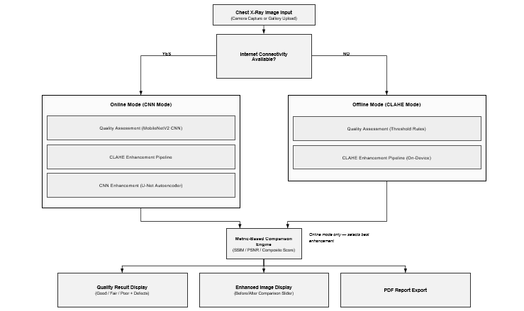

REFERENCES
Akinmoladun, J. A., Smart, A. E., & Atalabi, O. M. (2026). Artificial intelligence-enabled pediatric radiology in low-resource settings: Addressing resource constraints in the African healthcare system. Pediatric Radiology. https://doi.org/10.1007/s00247-025-06504-y
Al-Dhabyani, W., Alzahrani, A., & Alharthi, M. (2022). Hybrid CLAHE-CNN deep neural networks for classifying lung diseases from X-ray acquisitions. Electronics, 11(19), 3075. https://doi.org/10.3390/electronics11193075
Botwe, B. O., Akudjedu, T. N., Antwi, W. K., Jayson, G., Mkoloma, S., Bateman, S., Boadi, E., Rockson, P., & Schandorf, C. (2021). The integration of artificial intelligence in medical imaging practice: Perspectives of African radiographers. Radiography, 27(3), 861–866. https://doi.org/10.1016/j.radi.2021.01.008
Chen, Y., Stavropoulou, C., Frisher, M., Huckle, T., Smart, A., & de Lusignan, S. (2025). Artificial intelligence for diagnostics in radiology practice: A rapid systematic scoping review. eClinicalMedicine. https://doi.org/10.1016/j.eclinm.2025.103096
Garg, T., John, S., Abdulkarim, S., Ahmed, A. D., Kirubi, B., Rahman, M. T., Ubochioma, E., & Creswell, J. (2025). Implementation costs and cost-effectiveness of ultraportable chest X-ray with artificial intelligence in active case finding for tuberculosis in Nigeria. PLOS Digital Health, 4(6), e0000894. https://doi.org/10.1371/journal.pdig.0000894
Gelaw, S. M., Kik, S. V., Ruhwald, M., Ongarello, S., Egzertegegne, T. S., Gorbacheva, O., Gilpin, C., Marano, N., Lee, S., & Phares, C. R. (2023). Diagnostic accuracy of three computer-aided detection systems for detecting pulmonary tuberculosis on chest radiography when used for screening. PLOS Global Public Health, 3(7), e0000402. https://doi.org/10.1371/journal.pgph.0000402
Glocker, B., Jones, C., Nové-Josserand, M., & Crowson, M. (2024). The limits of fair medical imaging AI in real-world generalization. Nature Medicine, 30, 2277–2289. https://doi.org/10.1038/s41591-024-03113-4
Lunit Inc. (2025). Lunit INSIGHT CXR: Comprehensive chest X-ray AI detection software. Lunit. https://www.lunit.io/en/products/cxr
Meng, Y., Ruan, J., Yang, B., Gao, Y., Jin, J., Dong, F., & Tan, T. (2022). Automated quality assessment of chest radiographs based on deep learning and linear regression cascade algorithms. European Radiology, 32(11), 7680–7690. https://doi.org/10.1007/s00330-022-08771-x
Murphy, K., Smit, A., Philipsen, R. H. H. M., Scholten, E. T., Chanda-Kapata, P., Bates, M., Kapata, N., Jaeger, S., Zaidi, J., & Sánchez, C. I. (2020). Computer aided detection of tuberculosis on chest radiographs: An evaluation of the CAD4TB v6 system. Scientific Reports, 10(1), 5492. https://doi.org/10.1038/s41598-020-62148-y
Oakden-Rayner, L. (2017). Exploring the ChestXray14 dataset: Problems. Luke Oakden-Rayner’s Blog. https://lukeoakdenrayner.wordpress.com/2017/12/18/the-chestxray14-dataset-problems/
Rajpurkar, P., Irvin, J., Zhu, K., Yang, B., Mehta, H., Duan, T., Ding, D., Bagul, A., Langlotz, C., Shpanskaya, K., Lungren, M. P., & Ng, A. Y. (2017). CheXNet: Radiologist-level pneumonia detection on chest X-rays with deep learning. arXiv preprint arXiv:1711.05225. https://arxiv.org/abs/1711.05225
Rajpurkar, P., Irvin, J., Ball, R. L., Zhu, K., Yang, B., Mehta, H., Duan, T., Ding, D., Bagul, A., Langlotz, C., Shpanskaya, K., Yeom, K. W., Halabi, S. S., Patel, B. N., Lungren, M. P., & Ng, A. Y. (2018). Deep learning for chest radiograph diagnosis: A retrospective comparison of the CheXNeXt algorithm to practising radiologists. PLOS Medicine, 15(11), e1002686. https://doi.org/10.1371/journal.pmed.1002686
Reza, A. M. (2004). Realization of the contrast limited adaptive histogram equalization (CLAHE) for real-time image enhancement. Journal of VLSI Signal Processing Systems for Signal, Image, and Video Technology, 38(1), 35–44. https://doi.org/10.1023/B:VLSI.0000028532.53893.82
Song, L., Sun, H., Xiao, H., Lam, S. K., Zhan, Y., Ren, G., & Cai, J. (2024). Artificial intelligence for chest X-ray image enhancement: A review. Radiation Medicine and Protection, 6, 61–68. https://doi.org/10.1016/j.radmp.2024.11.005
Sridharan, S., Hui, A. S. X., Venkataraman, N., Tirukonda, P. S., Jeyaratnam, R. P., John, S., Suresh Babu, S., Liew, P., Francis, J., Tzan, T. K., Min, W. K., Liong, G. M., & Yee, C. L. J. (2024). Real-world evaluation of an AI triaging system for chest X-rays: A prospective clinical study. European Journal of Radiology, 181, 111783. https://doi.org/10.1016/j.ejrad.2024.111783
Stop TB Partnership. (2021). Screening and triage for TB using computer-aided detection (CAD) technology and ultra-portable X-ray systems: A practical guide. World Health Organization.
Vasilev, Y., Vladzymyrskyy, A., Omelyanskaya, O., Blokhin, I., Kirpichev, Y., & Arzamasov, K. (2023). AI-based CXR first reading: Current limitations to ensure practical value. Diagnostics, 13(8), 1430. https://doi.org/10.3390/diagnostics13081430
Wang, X., Peng, Y., Lu, L., Lu, Z., Bagheri, M., & Summers, R. M. (2017). ChestX-ray8: Hospital-scale chest X-ray database and benchmarks on weakly-supervised classification and localization of common thorax diseases. In Proceedings of the IEEE Conference on Computer Vision and Pattern Recognition (CVPR) (pp. 3462–3471). https://doi.org/10.1109/CVPR.2017.369
Zhang, H., Dullemond, H., Duchêne, S., Birnstiel, T., Okuzumi, S., Stammler, S. M., Henning, T., van der Marel, N., Veronesi, G., & Testi, L. (2024). Demographic bias of expert-level vision-language foundation models in medical imaging. Science Advances, 10(43), eadq0305. https://doi.org/10.1126/sciadv.adq0305

CHAPTER THREE: METHODOLOGY

3.1 Introduction
This chapter presents the methodology used to design and develop ClearScan, a hybrid mobile application for automated chest X-ray quality assessment and enhancement for Ghanaian healthcare facilities. It covers the system architecture, component design, requirements, software process model, logical design, and development tools used, shaped by the constraints identified in Chapter One: offline operation, computational efficiency on standard smartphones, and ease of use across varying levels of radiographer technical training.

3.2 Architecture of the Proposed System
ClearScan uses a three-tier client-server architecture, allowing each layer to be developed and tested independently: a Flutter mobile presentation layer handling image capture, result display, session history, and offline processing via embedded TFLite models and an OpenCV CLAHE pipeline; a FastAPI application logic layer (AWS EC2) that receives images via REST calls, runs CNN-based classification and autoencoder enhancement, and returns JSON responses; and an on-device processing layer mirroring the classical components - CLAHE, five quality metrics, and a TFLite classifier - for full offline operation. An adaptive mode-switching mechanism checks network presence then pings the backend health endpoint (3-second timeout) every 30 seconds; success activates CNN Mode, failure defaults to CLAHE Offline Mode, ensuring connectivity issues never interrupt clinical workflow:

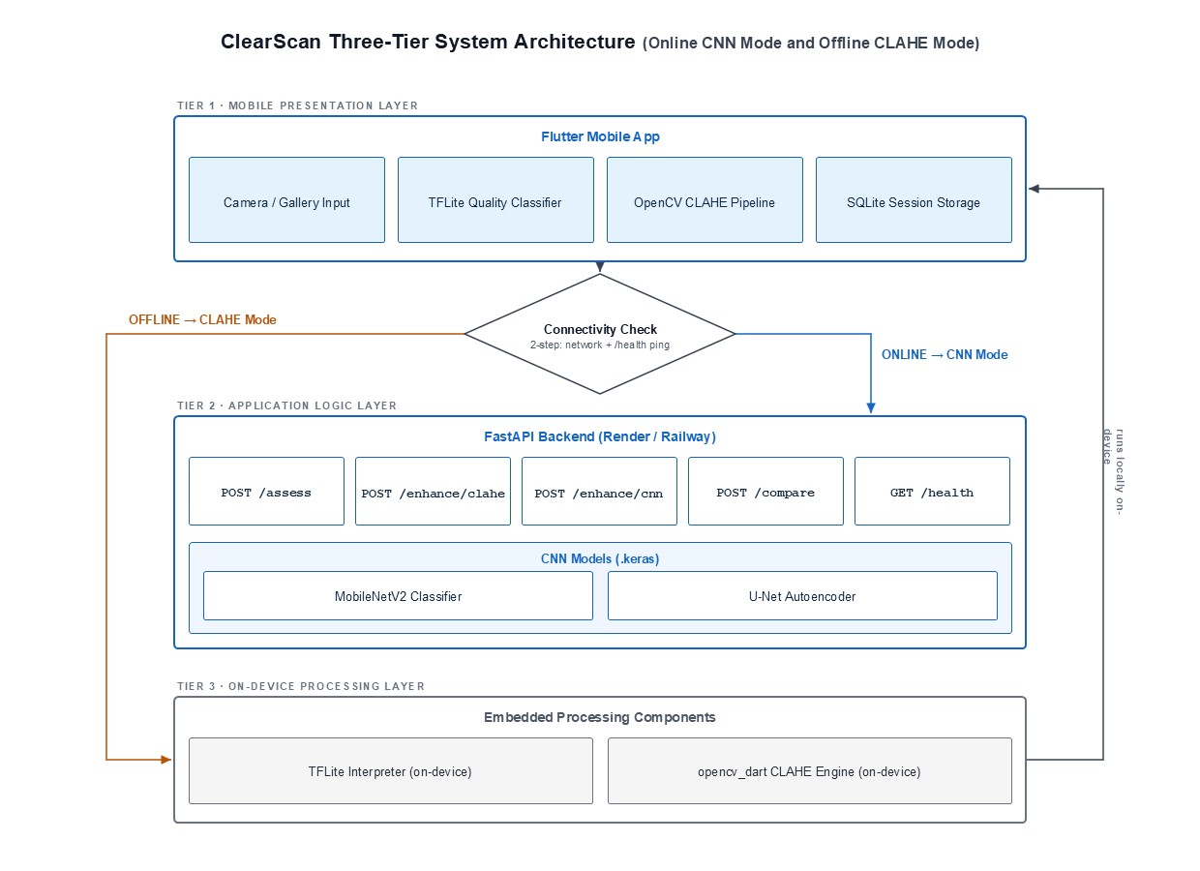
Figure 3.1: ClearScan Three-Tier System Architecture (Online CNN Mode and Offline CLAHE Mode)

3.3 Component Design and Descriptions
ClearScan comprises six components with clearly defined responsibilities:
Component | Function
Image Preprocessing | Decodes input, converts to grayscale, resizes to 512×512, and normalises to [0,1]; implemented identically in Python and Dart for consistent output across both paths.
Quality Assessment | Computes five no-reference metrics (Table 3.2) on every image, supplemented online by a MobileNetV2 CNN classifier chosen for its lightweight convolutions suited to mobile and backend inference (Howard et al., 2017). Outputs a quality class, confidence score, and defect labels derived from threshold violations.
CLAHE Enhancement Pipeline | On-device pipeline via opencv_dart: CLAHE (clip 2.0, tile 8×8) for contrast (Reza, 2004), Non-Local Means Denoising (h=7), then Unsharp Masking (σ=1.0, amount=1.5) — sequence validated by Al-Dhabyani et al. (2022).
CNN Enhancement (U-Net) | Online-only autoencoder selected for skip connections that preserve detail and avoid blurring artefacts (Ronneberger et al., 2015). Trained on 512×512 pairs with a 50% MSE + 50% (1−SSIM) loss; exported to TFLite (<15MB target).
Comparison Engine | Online; scores CLAHE and CNN outputs via SSIM, PSNR, and BRISQUE using the composite formula below, returning the higher-scoring image with both outputs visible to the user.
Synthetic Degradation Pipeline | Generates CNN training data via six controlled degradations (Table 3.3) on clean JSRT/Montgomery images, addressing the scarcity of paired clinical quality datasets (Song et al., 2024).
Table 3.1: ClearScan System Components

Metric | Quality Dimension | Poor Threshold
Laplacian Variance — Var(∇²I) | Sharpness / Motion Blur | < 50
RMS Contrast — √(Σ(Iᵢ−μ)²/N) | Contrast / Exposure | < 20
Shannon Entropy — −Σ p(i) log₂ p(i) | Information Content | < 3.5
Histogram Spread — P₉₅ − P₅ | Exposure Range | < 80
Noise Variance — σ̂ of smooth regions | Signal-to-Noise Ratio | > 0.05
Table 3.2: No-Reference Quality Metrics Used in ClearScan

Degradation Type | Parameter Range | Real-World Analogue
Gaussian Blur | σ ∈ [0.8, 3.5] | Patient movement during exposure
Gaussian Noise | Variance ∈ [0.005, 0.05] | Electronic sensor noise
Poisson Noise | Scale ∈ [0.3, 1.0] | Quantum noise in low-dose imaging
Underexposure | Multiplier ∈ [0.3, 0.7] | Incorrect exposure setting
Contrast Compression | Spread: 30–60% of original | Overexposure / flat histogram
Combined Degradation | Random pair of above types | Multiple simultaneous defects
Table 3.3: Synthetic Degradation Types and Clinical Analogues

3.4 Evaluation and Analysis of Software System Type
ClearScan is a mobile-first, AI-assisted clinical decision support application — a stand-alone application offline and an interactive transaction-based application online. As a reliability-critical decision support tool, it mandates offline fallback, an explicit mode indicator, and frames all outputs as decision support rather than diagnosis. It is not a regulated diagnostic device and performs no disease detection.

3.5 Functional Requirements of the Proposed System
- FR-01: Accept chest X-ray images via camera capture or gallery selection on Android and iOS.
- FR-02: Compute five quality metrics and classify images as Good, Fair, or Poor with defect labels.
- FR-03: Apply CLAHE enhancement on-device for all Fair/Poor images, without network dependency.
- FR-04: Apply CNN enhancement via the backend when online, comparing outputs using composite scoring.
- FR-05: Display SSIM, PSNR, BRISQUE scores and a draggable before/after comparison slider.
- FR-06: Persist session history locally via SQLite, filterable by quality class and time period.
- FR-07: Export results as a PDF report and allow saving enhanced images to the gallery.
- FR-08: Display and auto-switch the active processing mode based on backend availability.

3.6 Identification of Stakeholders
Four stakeholder groups are identified for ClearScan. Radiographers are the primary end users — they capture images and use ClearScan's outputs to judge image acceptability before radiologist review, particularly important in district hospitals with infrequent radiologist oversight. Radiologists are secondary users who receive pre-screened, potentially enhanced images, relying on assessment reliability and the PDF export as a clinical audit record. Hospital and clinic administrators are indirect stakeholders responsible for approving and managing the system's deployment, and have an interest in its cost-effectiveness, offline reliability, and impact on reducing repeat scan rates. The system developer/maintainer is also a stakeholder, responsible for the ongoing maintenance of the backend infrastructure, model updates, and resolution of any deployment issues that arise post-handover.

3.7 Requirement Gathering Process
Requirements were gathered through three complementary approaches. Document and Standard Review involved consulting the WHO Technical Manual on Chest X-Ray Quality Assurance and British Institute of Radiology (BIR) guidelines to establish the radiographic quality criteria and threshold values used throughout the system, ensuring that the quality metrics and clinical workflow constraints reflect established clinical protocols rather than arbitrary technical choices. Literature Review Synthesis drew on the six research gaps identified in Chapter Two — particularly the absence of mobile-deployable, offline-capable quality assessment tools — which directly shaped the functional and non-functional requirements, with each gap mapped to at least one functional requirement in Section 3.5. Comparative System Analysis examined existing tools such as CheXNet, CAD4TB, and Lunit INSIGHT CXR to identify functional capabilities worth replicating and limitations worth addressing in ClearScan's design.

3.8 Requirement Specification

3.8.1 Functional User Requirements

ID | User Requirement | Stakeholder
FUR-01 | As a radiographer, I want to upload or capture a chest X-ray so I can receive an automated quality assessment. | Radiographer
FUR-02 | As a radiographer, I want to see a quality label with defects identified so I know what is wrong and whether a repeat scan is needed. | Radiographer
FUR-03 | As a radiographer, I want the app to work without internet so I can use it in clinics with poor connectivity. | Radiographer
FUR-04 | As a radiographer, I want to compare original and enhanced images side by side to see the improvement. | Radiographer
FUR-05 | As a radiographer, I want to export a PDF report for clinical records. | Radiographer / Radiologist
FUR-06 | As a radiologist, I want to know what enhancement was applied to an image before I interpret it. | Radiologist
Table 3.4: Functional User Requirements

3.8.2 Functional System Requirements

ID | System Requirement | Satisfies
FSR-01 | The system shall decode JPEG and PNG images into a 512×512 grayscale normalised pixel array. | FUR-01
FSR-02 | The system shall compute all five metrics and return quality class and defect labels within 1 second in offline mode. | FUR-02, FUR-03
FSR-03 | The system shall classify quality using MobileNetV2 CNN when online and threshold rules when offline, with automatic fallback. | FUR-02, FUR-03
FSR-04 | The system shall apply the three-stage CLAHE pipeline entirely on-device for all Fair or Poor images. | FUR-03
FSR-05 | The system shall compute SSIM, PSNR, and BRISQUE composite scores and display the winning enhancement method. | FUR-04, FUR-06
FSR-06 | The system shall generate a PDF report with image thumbnails, metric values, and enhancement comparison within 4 seconds. | FUR-05, FUR-06
Table 3.5: Functional System Requirements

3.8.3 UML Diagrams
Use Case Diagram 1 — Mobile Application (Front-End)
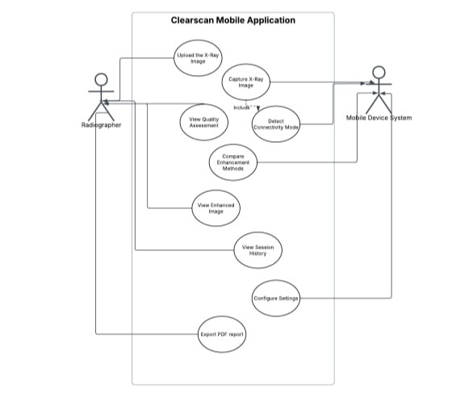
Figure 3.2: Use Case Diagram — ClearScan Mobile Application (Front-End)

Use Case Description — UC-01: View Quality Assessment

Element | Description
Actor(s) | Radiographer, Mobile Device System
Precondition | An image has been submitted via upload or camera capture.
Main Flow | 1. System computes five quality metrics. 2. If online, image is sent to backend CNN classifier. 3. Quality badge (Good/Fair/Poor), confidence score, defect chips, and metric bars are displayed. 4. Session record is written to SQLite.
Alternative Flow | If offline, CNN classification is skipped and quality class is determined from metric thresholds. Mode chip shows ‘Offline Mode’. If backend times out, system falls back to offline classification.
Postcondition | Quality class, defect list, confidence, and metrics are displayed and persisted.
Performance | Total assessment time shall not exceed 3 seconds online or 1 second offline.
Table 3.6: Use Case Description — UC-01: View Quality Assessment

Use Case Description — UC-02: View Enhanced Image

Element | Description
Actor(s) | Radiographer
Precondition | Quality assessment is complete and image class is Fair or Poor.
Main Flow | 1. Radiographer taps 'Enhance Image'. 2. If online, both CLAHE and CNN enhancement are applied. 3. Comparison slider displays original (left) and enhanced (right). 4. SSIM, PSNR, and BRISQUE before/after values are shown. 5. Winner banner displays the superior method and composite score.
Alternative Flow | If offline, only CLAHE enhancement is applied. The mode toggle is disabled.
Postcondition | Enhanced image and before/after metrics are displayed. Enhanced image can be saved to gallery.
Performance | CLAHE enhancement within 3 seconds; CNN enhancement within 8 seconds.
Table 3.7: Use Case Description — UC-02: View Enhanced Image

Use Case Diagram 2 — Backend System (Back-End)
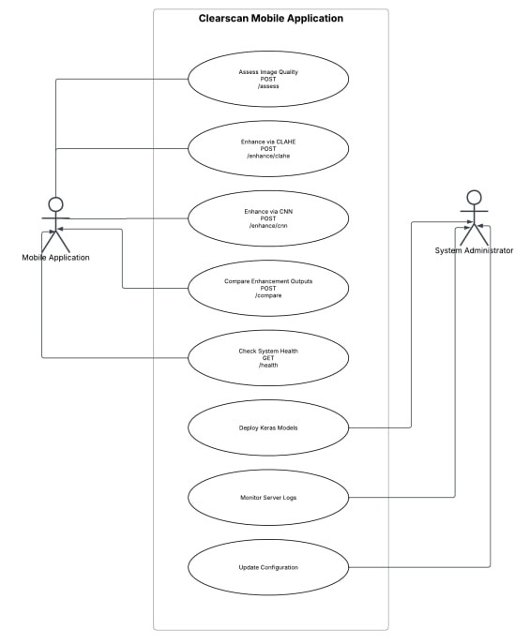
Figure 3.3: Use Case Diagram — ClearScan FastAPI Backend (Back-End)

Activity Diagram — Full Assessment and Enhancement Flow
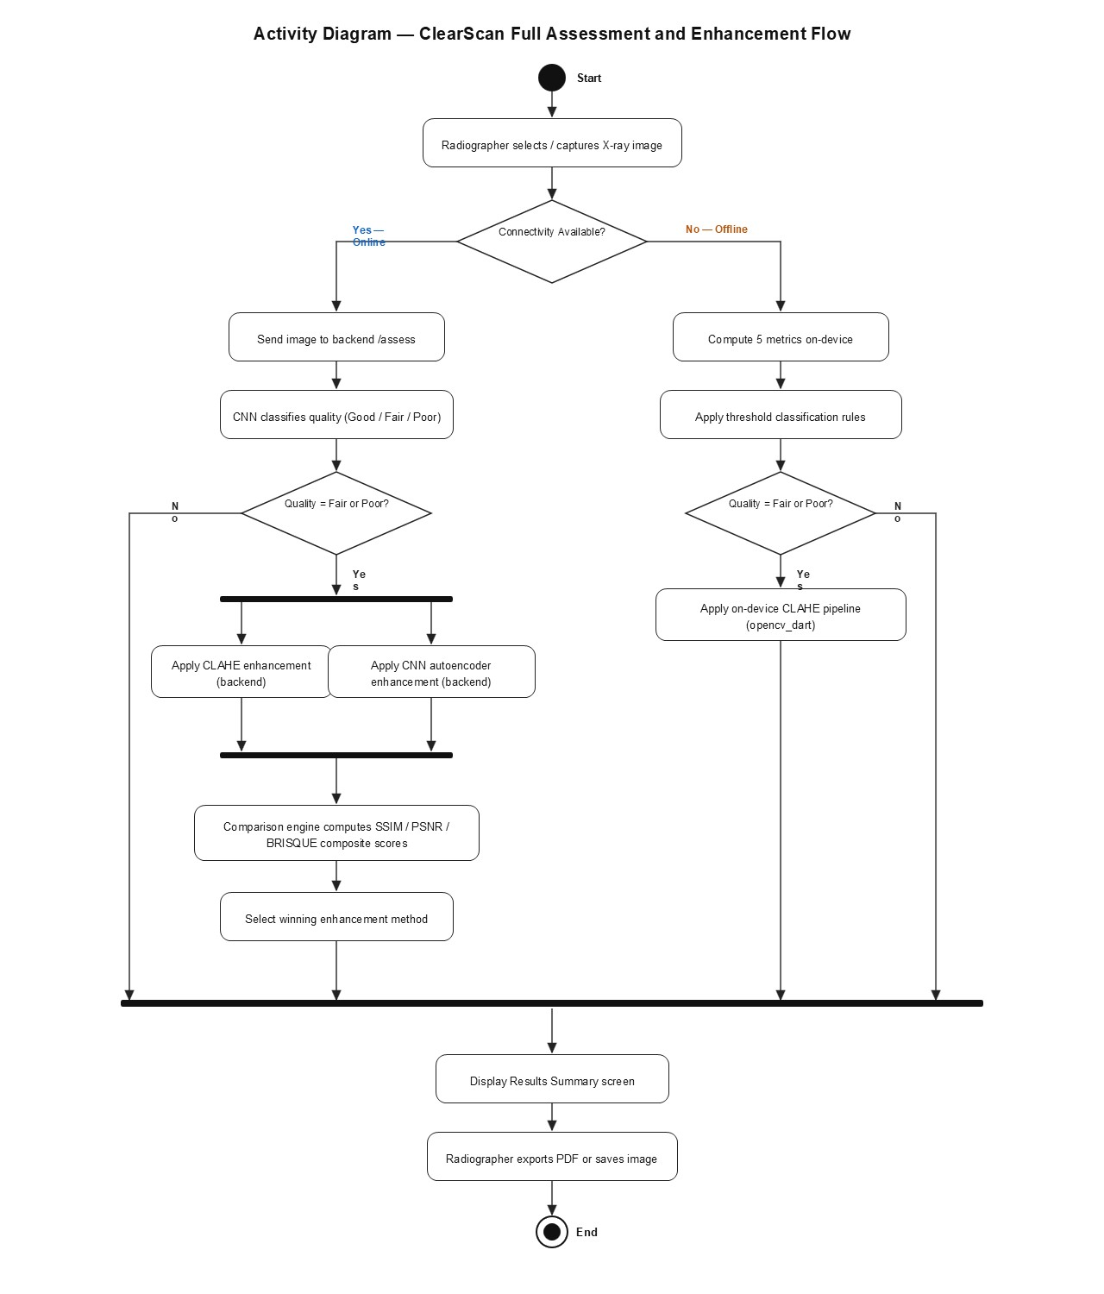
Figure 3.4: Activity Diagram — ClearScan Assessment and Enhancement Flow
Sequence Diagram — Online Mode
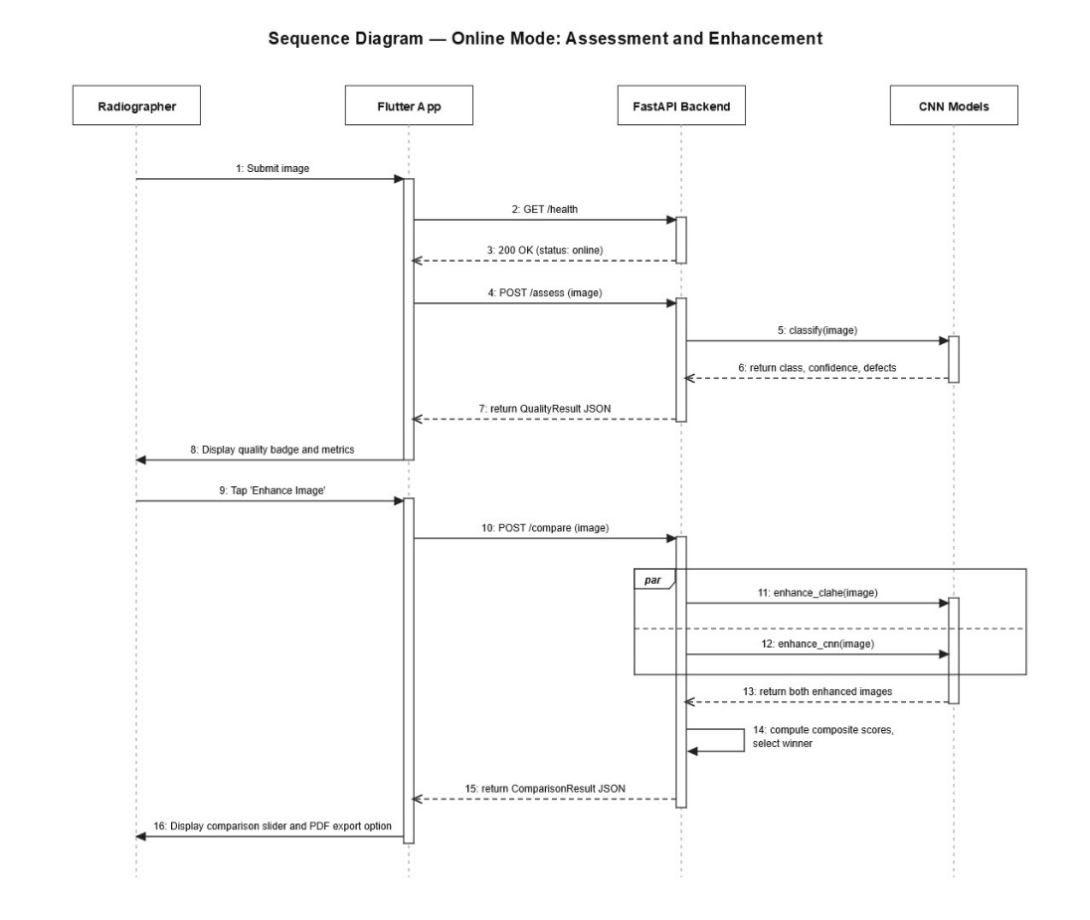
Figure 3.5: Sequence Diagram — Online Mode: Assessment and Enhancement
Sequence Diagram — Offline Mode

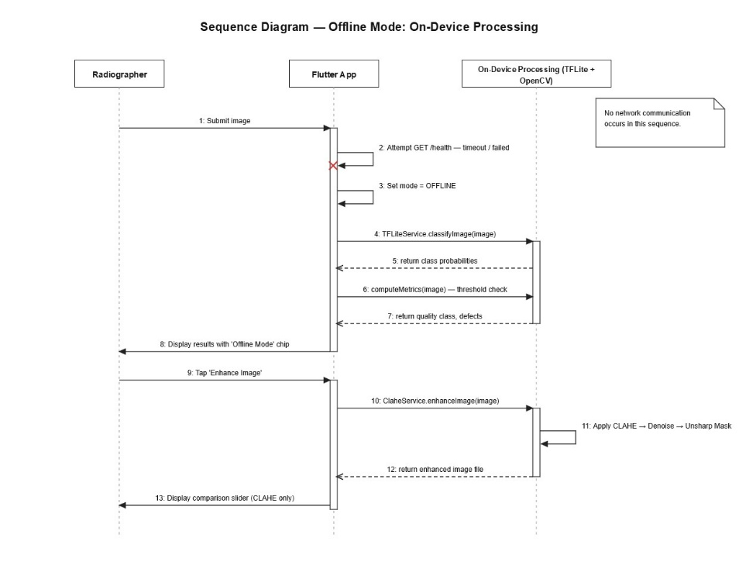
Figure 3.6: Sequence Diagram — Offline Mode: On-Device Processing

3.9 Non-Functional Requirements
ID | Category | Requirement | Justification
NFR-01 | Performance | Offline quality assessment shall complete within 1 second on any Android device with 2 GB RAM. | Consistent with user tolerance thresholds (Nielsen, 1994); necessary for clinical workflow efficiency.
NFR-02 | Performance | Online CNN assessment shall complete within 3 seconds end-to-end including network round-trip. | Derived from Chapter One specific objective. Accounts for estimated 200–500ms Ghana-to-server network latency.
NFR-03 | Reliability | The system shall remain fully functional for assessment and CLAHE enhancement with no internet connectivity for indefinite periods. | District hospital connectivity outages are frequent in Ghana. Offline reliability is a core, not optional, requirement.
NFR-04 | Reliability | The system shall fall back to offline mode automatically within 3 seconds of backend unavailability. | Automatic failover ensures connectivity failures are transparent and do not interrupt clinical workflow.
NFR-05 | Usability | All quality status indicators shall use both colour and text labels. | Satisfies WCAG 2.1 accessibility guidelines (W3C, 2018); ensures colour-blind users can interpret assessments.
NFR-06 | Portability | The app shall run on Android API level 21+ and iOS 12.0+. | Covers approximately 99% of active Android devices (Android Developer Dashboard, 2024).
NFR-07 | Security | No patient image data shall be transmitted to any third-party service. | Complies with Ghana's Data Protection Act 2012 (Act 843) data minimisation principle.
Table 3.8: Non-Functional Requirements with Justifications

3.10 Candidate Classes and UML Class Diagram
The following candidate classes are identified from the system's functional requirements. Each encapsulates a distinct responsibility with well-defined interfaces to adjacent classes.
Class | Layer | Responsibility
XRayImage | Shared | Core data entity. Encapsulates raw pixel array, file path, dimensions, and grayscale normalised data.
QualityMetrics | Assessment | Computes and stores all five no-reference metrics. Provides computeMetrics(image: XRayImage) → MetricsDict.
QualityClassifier | Assessment | Wraps MobileNetV2 CNN (online) or threshold rules (offline). Provides classify() → QualityResult.
QualityResult | Assessment | Value object: quality class, confidence score, class probabilities, defect list.
ClaheEnhancer | Enhancement | Applies three-stage CLAHE pipeline on-device. Provides enhance(image) → XRayImage.
CnnEnhancer | Enhancement | Invokes FastAPI CNN endpoint. Provides enhance(image) → XRayImage.
ComparisonEngine | Comparison | Computes SSIM, PSNR, BRISQUE, composite scores. Provides compare() → ComparisonResult.
SessionRepository | Persistence | CRUD operations on local SQLite database for SessionRecord objects.
Table 3.9: ClearScan Candidate Classes
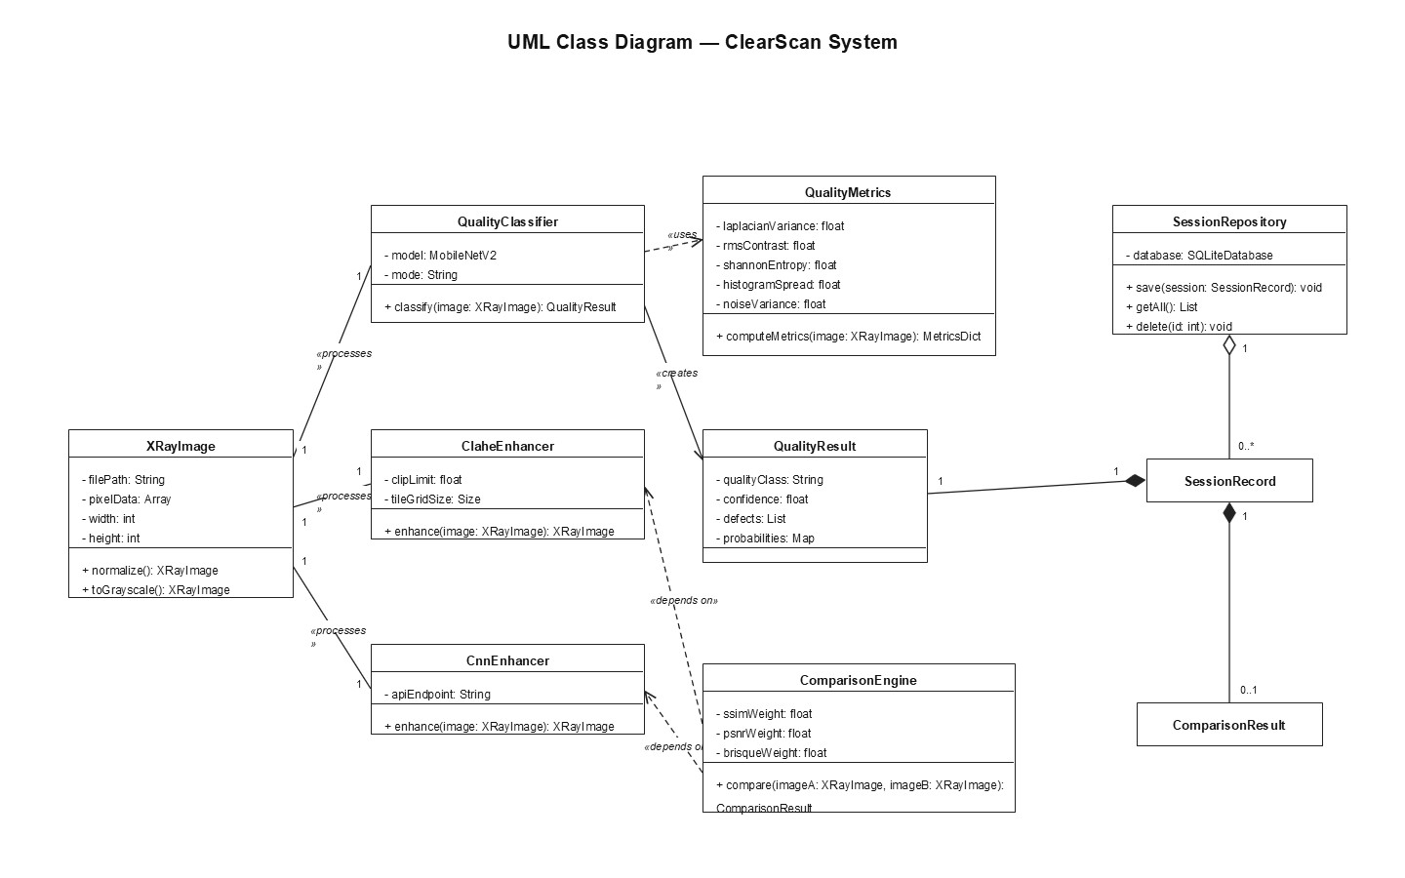Figure 3.7: UML Class Diagram — ClearScan System
Key relationships: XRayImage is the central entity associated with all processing classes. QualityClassifier uses QualityMetrics (dependency) and produces QualityResult (creates). ComparisonEngine depends on ClaheEnhancer and CnnEnhancer outputs. SessionRepository manages a one-to-many collection of SessionRecord objects, each aggregating one QualityResult and zero-or-one ComparisonResult.

3.11 Algorithms for the System

3.11.1 Algorithm 1: Quality Assessment

Step | Operation
Input | Grayscale image I (512×512), connectivity status C
Step 1 | Normalise I to [0,1]. Compute metrics: LV, RC, SE, HS, NV.
Step 2 | IF C = ONLINE: send I to CNN classifier → class probabilities [p_Good, p_Fair, p_Poor]; SET Q = argmax(probabilities); SET confidence = max(probabilities).
Step 3 | IF C = OFFLINE: IF LV<50 OR NV>0.05 OR RC<20 THEN Q=Poor; ELSE IF LV>200 AND RC>60 AND NV<0.01 THEN Q=Good; ELSE Q=Fair.
Step 4 | Derive defect list D: ADD 'motion_blur' if LV<50; ADD 'underexposure' if RC<20; ADD 'excessive_noise' if NV>0.05; ADD 'low_contrast' if HS<80; ADD 'overexposure' if HS>230.
Output | QualityResult {class: Q, confidence, defects: D, metrics: M}
Table 3.10: Algorithm 1 — Quality Assessment

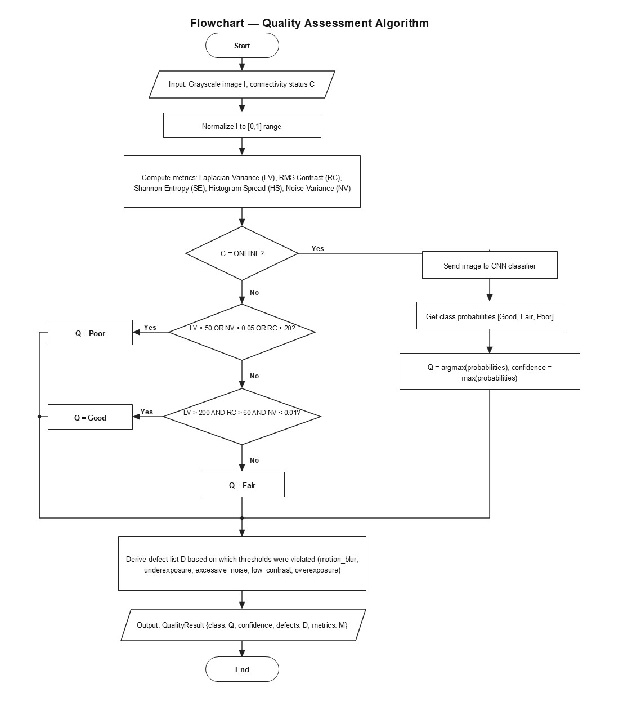
Figure 3.8: Flowchart — Quality Assessment Algorithm

3.11.2 Algorithm 2: Hybrid Enhancement and Selection

Step | Operation
Input | Image I, quality class Q, connectivity status C
Step 1 | IF Q = Good: RETURN I unchanged (no enhancement needed).
Step 2 | Apply CLAHE pipeline: I_CLAHE = UnsharpMask(NLMeans(CLAHE(I))).
Step 3 | IF C = OFFLINE: RETURN I_CLAHE as final output.
Step 4 | IF C = ONLINE: send I to CNN autoencoder → I_CNN.
Step 5 | Compute composite scores for I_CLAHE and I_CNN using formula in Section 3.3.5.
Step 6 | IF Score_CNN > Score_CLAHE: winner = 'CNN'; ELSE winner = 'CLAHE'. RETURN winner image, all scores, both enhanced images.
Output | ComparisonResult {best_image, winner, clahe_metrics, cnn_metrics, composite_scores}
Table 3.11: Algorithm 2 — Hybrid Enhancement and Selection

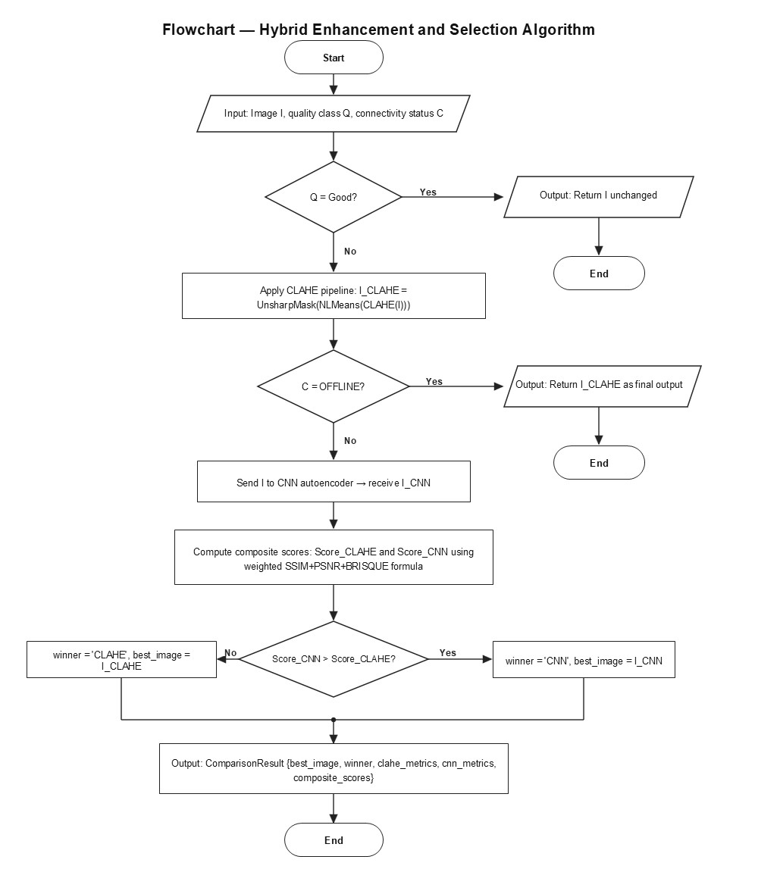
Figure 3.9: Flowchart — Hybrid Enhancement and Selection Algorithm

3.12 Project Methods to be Employed

ClearScan adopts a plan-driven development approach, as the project's requirements — derived from the literature review, stakeholder needs, and technical specifications in Chapters One and Two — are well-defined upfront and unlikely to change significantly during development. This contrasts with an agile approach, which is better suited to projects with evolving or loosely defined requirements. Given the two-person team, fixed 15-week timeline, and clearly separable system components (machine learning pipeline, backend API, and mobile application), a plan-driven methodology provides the structure needed to sequence development predictably while still allowing incremental delivery and risk management

3.13 Software Process Model
ClearScan adopts the Incremental Development Model, delivering full requirements through four planned increments:
Increment | Deliverable | Components | Weeks
1 | Quality Assessment Core | Preprocessing, five metrics, threshold classifier, basic mobile UI | 5–7
2 | Enhancement Pipeline | CLAHE module, U-Net autoencoder training, comparison slider UI | 7–10
3 | Online CNN Mode and Backend | FastAPI endpoints, CNN classifier integration, comparison engine, mode switching | 10–12
4 | Complete Mobile Application | SQLite history, PDF export, settings, all remaining screens | 12–14
Table 3.12: ClearScan Incremental Development Plan
This model was chosen because ClearScan's separable components (ML pipeline, backend, mobile app) map naturally to increments with requirements known upfront, unlike Agile/Scrum which suits evolving requirements. Delivering a working assessment module first validates core feasibility early and reduces integration risk, which is preferable to the heavyweight upfront design of Waterfall given the two-person team and 15-week timeline.

3.14 Project Design Considerations (Logical Designs)

3.14.1 UI Design
ClearScan's interface follows a clinical, minimal design language — white backgrounds, blue (#1565C0) primary colour, DM Sans typeface — for readability under variable hospital lighting. The design spans twelve screens: Splash and Onboarding, Home, Image Preview, Assessment (loading/results), Enhancement (loading/results), Results Summary, Session History, and Settings, produced using a dedicated design tool and presented in Figures 3.10–3.21.

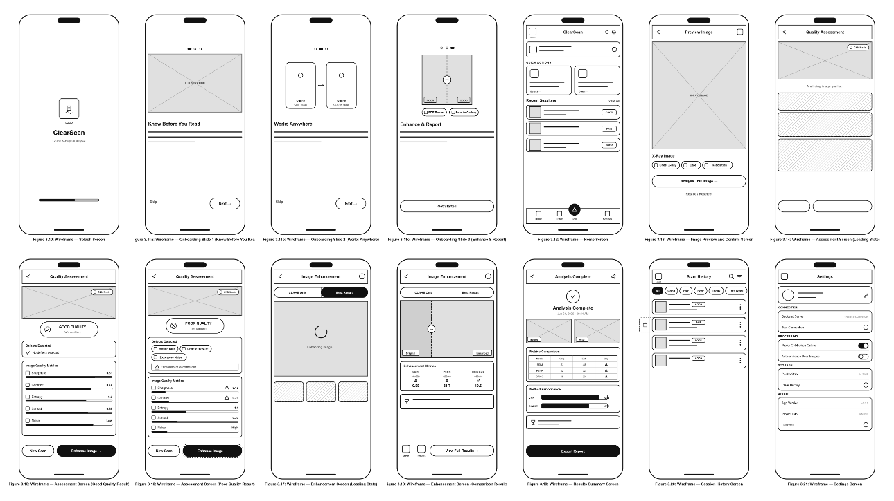
Figures 3.10–3.21: ClearScan UI Wireframes

3.14.2 Database Design
ClearScan uses a local SQLite database for session history; the backend is entirely stateless. The schema comprises two normalised tables: sessions (session metadata, quality class, enhancement method, mode) and metrics (metric name-value pairs linked to sessions via foreign key with CASCADE DELETE), avoiding JSON blob storage and supporting efficient filtering.
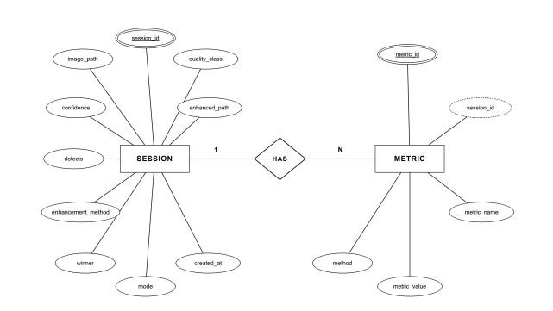
Figure 3.22: Entity-Relationship Diagram

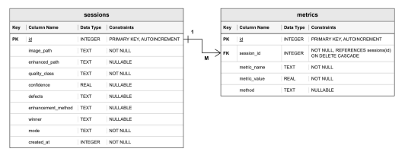

Figure 3.23 Database Schema

3.15 Development Tools
Table 3.13 summarises the primary development tools used in ClearScan, with specific reference to their role in the methodology described in this chapter.
Tool | Version | Role in ClearScan
Flutter / Dart | ≥ 3.19.0 | Cross-platform mobile development for all 12 application screens, on-device TFLite inference, OpenCV CLAHE integration, SQLite persistence, and PDF export.
FastAPI (Python) | 0.110.1 | REST API server exposing four image processing endpoints. Selected over Flask for its async request handling and automatic Pydantic input validation.
TensorFlow / Keras | 2.15.0 | CNN model definition, training (MobileNetV2 classifier and U-Net autoencoder), and export to both .keras (backend) and .tflite (mobile) formats.
OpenCV | 4.9.0 | Image preprocessing, CLAHE implementation, non-local means denoising, and unsharp masking — used in both the Python backend and via opencv_dart in Flutter.
AWS EC2 (g4dn.xlarge) | NVIDIA T4 | GPU-accelerated model training only. Used exclusively during Increments 2 and 3; stopped immediately after training to minimise cost (~$0.53/hr).
AWS EC2 (t3.medium) | 2 vCPU / 4 GB | Cloud deployment of the FastAPI backend via Docker container. Continuous deployment from GitHub repository.
Lucidchart | — | All UML diagrams, architecture diagrams, flowcharts, and ER diagrams presented in this chapter.
Table 3.13: Development Tools and Their Role in ClearScan
CHAPTER FOUR
IMPLEMENTATION, TESTING, AND RESULTS

4.1 IMPLEMENTATION

4.1.1 Introduction
This chapter presents the implementation of the system. The implementation follows the four incremental phases defined in Chapter Three: quality assessment core, enhancement pipeline, online CNN mode and backend, and complete mobile application. Each module is described in terms of its implementation approach, key design decisions, and representative code extracts. Testing results and system performance metrics are presented in Sections 4.2 and 4.3 respectively.
The system was implemented across three primary environments: a Python-based machine learning pipeline trained on an AWS EC2 g4dn.xlarge GPU instance (NVIDIA Tesla T4, 16 GB VRAM), a FastAPI backend deployed via Docker on an AWS EC2 t3.medium instance, and a Flutter mobile application targeting Android and iOS platforms. All source code is version-controlled on GitHub.
Sections 4.1.4 to 4.1.9 present the six core components of ClearScan as defined in Chapter Three (Table 3.1). These headings are named after the system's actual modules rather than the generic template headings (Login Module, Hashing Method, Checksum Data Recovery, and Data Shuffling), because ClearScan performs chest X-ray quality assessment and enhancement and therefore has no login, hashing, checksum-recovery, or data-shuffling functionality.

4.1.2 Implementation of the Frontend
The ClearScan mobile frontend was developed using Flutter (version 3.19.0), a cross-platform framework that compiles a single Dart codebase to native Android and iOS binaries. The design follows a clinical and minimal language, white backgrounds, Primary Blue (#1565C0), and the DM Sans typeface, ensuring readability under the variable lighting conditions of hospital environments.
The frontend is organized into a feature-based folder structure under lib/, with dedicated subdirectories for core services, feature screens, Riverpod state providers, and shared models. State management is handled exclusively through Flutter Riverpod, providing reactive, testable state across the application's screens without relying on inherited widget trees or global singletons.
UI Designs
The application comprises a set of primary screens covering the core assessment workflow. The Splash Screen displays the ClearScan logo with an animated progress bar for two seconds on launch. The Onboarding flow, shown only on first launch, guides users through three slides introducing quality assessment, online/offline modes, and enhancement capabilities. The Home Screen presents quick action cards for image upload and camera capture, a recent sessions list, a bottom navigation bar with a center floating action button, and a connectivity indicator dot in the AppBar. The Assessment Screen displays the X-ray image, a colour-coded quality badge (Good/Fair/Poor) with confidence score, defect chips, and animated metric progress bars. The Enhancement Screen features a draggable before/after comparison slider, SSIM/PSNR/BRISQUE before-and-after metrics, and a winner banner identifying the superior enhancement method. The Results Summary Screen displays before/after thumbnails, a metrics comparison table, a bar chart of method performance, and an Export button. The Session History Screen lists past scans with filter chips and swipe-to-delete. The Settings Screen provides backend URL configuration, processing toggles, and storage management.
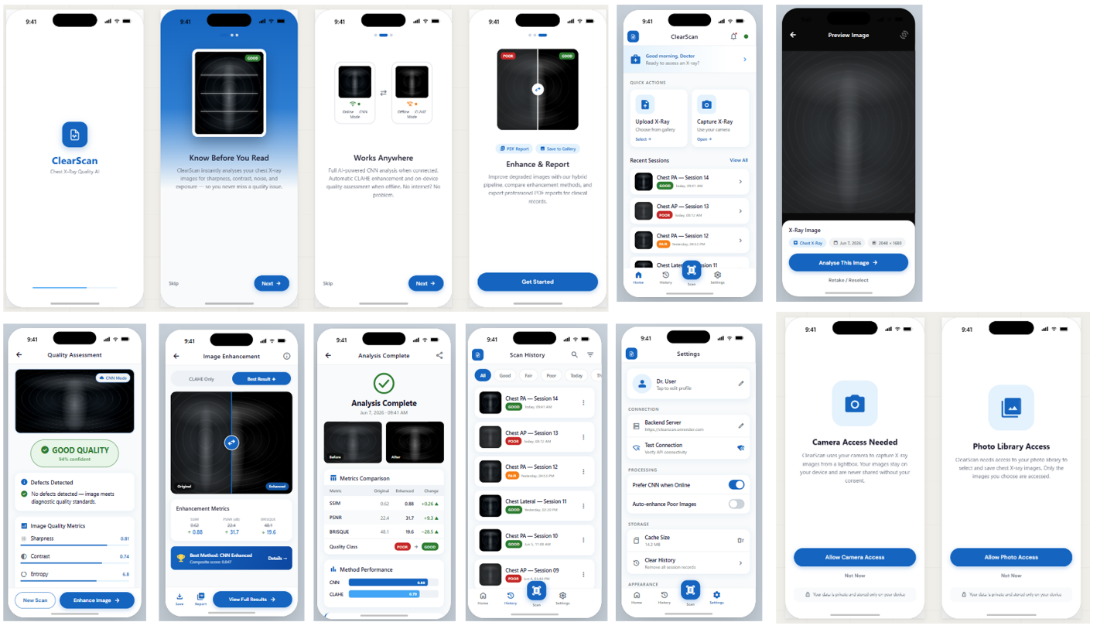
Figure 4.1: ClearScan Mobile Application – UI Screens

UI Code Listing
The following extract shows the connectivity service implementation, which governs the adaptive mode-switching between CNN Mode (online) and CLAHE Offline Mode:
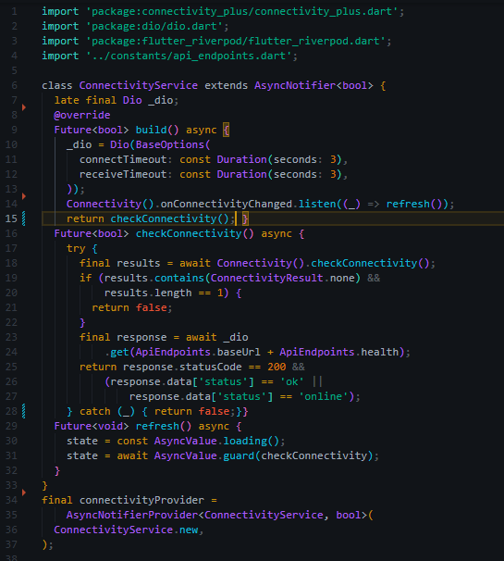
Code Listing 4.1: ConnectivityService.dart — adaptive mode switching logic
The ComparisonSlider widget, which is the application's most technically complex UI component, implements a draggable vertical divider using Pointer events to update slider position as a percentage of panel width. A first-load hint animation automatically slides the divider from 50% to 35% and back over 1.2 seconds to indicate draggability to first-time users:
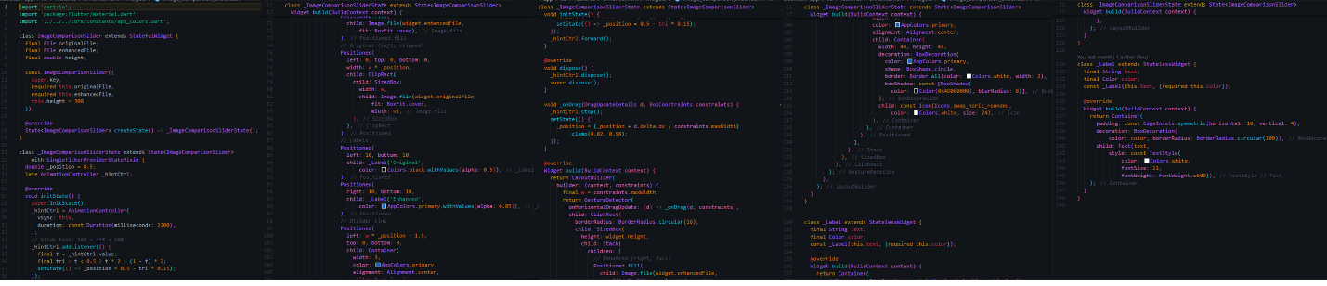
Code Listing 4.2: ComparisonSlider widget - draggable before/after image comparison

4.1.3 Implementation of the Backend
The ClearScan backend is a FastAPI application (version 0.110.1) running on Python 3.10, deployed via a Docker container to an AWS EC2 t3.medium instance. The backend is designed as a stateless service - it receives an image, processes it through the ML pipeline, and returns a structured JSON response, retaining no persistent state between requests.
Backend Designs
The backend exposes five REST endpoints under the /api/v1/ prefix. The health endpoint (GET /health) performs a lightweight liveness check and returns the loaded status of both Keras models, enabling the Flutter application's two-step connectivity check. The assess endpoint (POST /assess) accepts a multipart image upload, runs the quality metric computation and CNN classifier, and returns a QualityAssessmentResponse containing quality class, confidence, defect labels, and all five metric values. The enhance endpoints (POST /enhance/clahe and POST /enhance/cnn) apply the respective enhancement pipeline and return the enhanced image encoded as Base64 with before/after metric scores. The compare endpoint (POST /compare) applies both enhancement methods in parallel, computes composite scores, and returns the superior output.
Both Keras models are loaded as singletons at application startup via a FastAPI startup event. If either model file is absent, the singleton sets its internal model reference to None and serves HTTP 503 responses for the affected endpoints, allowing the application to fall back to offline mode rather than crashing entirely.

Endpoint | Method | Function
GET /api/v1/health | GET | Returns server status and model load state for connectivity check
POST /api/v1/assess | POST | Quality metric computation + CNN classification → QualityResult
POST /api/v1/enhance/clahe | POST | Classical CLAHE pipeline → enhanced image + before/after metrics
POST /api/v1/enhance/cnn | POST | U-Net autoencoder enhancement → enhanced image + metrics
POST /api/v1/compare | POST | Both methods + composite scoring → winning enhanced image
Table 4.1: ClearScan FastAPI Backend Endpoints
Backend Code Listing
The following extract illustrates the /compare endpoint, which orchestrates both enhancement pipelines and the comparison engine within a single request:
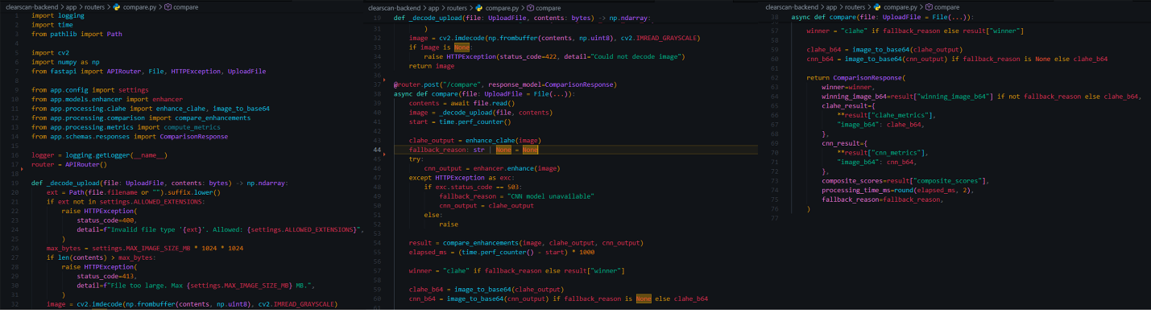
Code Listing 4.3: compare router - dual enhancement and composite scoring
The composite scoring formula implemented in comparison.py weights SSIM and PSNR equally at 0.4 each, with BRISQUE contributing 0.2 as a no-reference perceptual quality check:
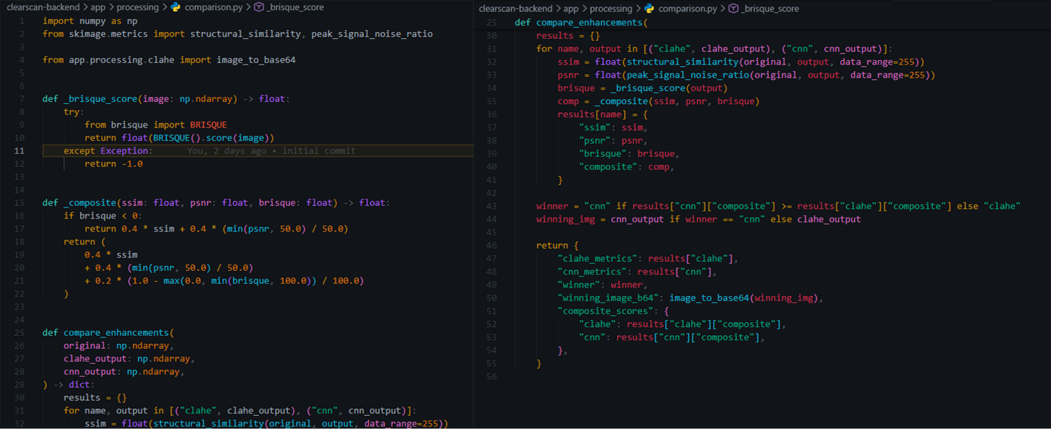
Code Listing 4.4: comparison.py - composite score computation

4.1.4 The Quality Assessment Module
The Quality Assessment Module implements the five no-reference image quality metrics described in Chapter Three and integrates the MobileNetV2 CNN classifier for online quality classification. The module is implemented in Python for the backend (quality_metrics.py and classifier.py) and in Dart for on-device offline classification using TensorFlow Lite.
The five metrics - Laplacian variance, RMS contrast, Shannon entropy, histogram spread, and noise variance, are computed on every submitted image regardless of connectivity. When online, the CNN classifier supplements these metrics by predicting quality class probabilities from the image directly, providing higher accuracy than the threshold-based rules alone. The classifier outputs the predicted class, a confidence score, and class probabilities for all three categories, from which defect labels are derived based on which threshold conditions are violated.
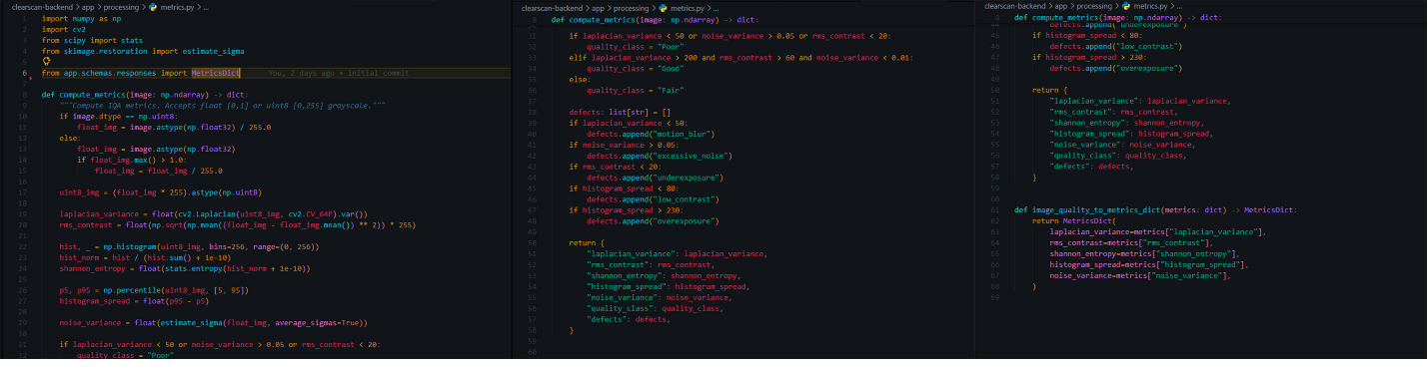
Code Listing 4.5: quality_metrics.py - five metric computation and threshold classification

4.1.5 The Image Upload and Capture Module
The Image Upload and Capture Module is implemented in Flutter using the image_picker package (version 1.0.7). The module supports two acquisition modes: gallery upload, which opens the device's native photo library for image selection, and camera capture, which activates the device camera directly. Both paths are accessible from the Home Screen via the Quick Action cards and from the centre floating action button in the bottom navigation bar.
After image selection, the module validates the file extension against the permitted list (.png, .jpg, .jpeg) and displays the image on the Preview Screen for user confirmation before submission to the assessment pipeline. Images are decoded using OpenCV in both the Flutter frontend (for offline processing) and the FastAPI backend (for online processing), ensuring consistent preprocessing across both paths. All images are resized to 512×512 pixels using bicubic interpolation before metric computation and enhancement model inference. A separate resize to 224×224 is applied before quality classifier inference, matching the MobileNetV2 input requirement.
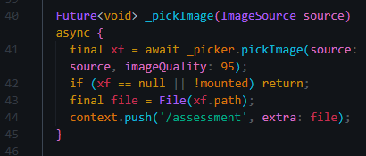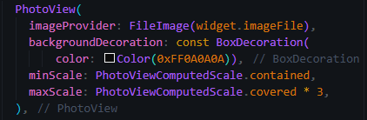
Code Listing 4.6: image picker and preview - Flutter implementation

4.1.6 The CLAHE Enhancement Module
The CLAHE Enhancement Module implements the three-stage classical image enhancement pipeline described in Chapter Three. It operates in two deployment contexts: on the FastAPI backend for online enhancement requests (POST /enhance/clahe) and on the mobile device using the opencv_dart package for offline enhancement without network dependency.
The pipeline applies operations in the following sequence. First, CLAHE is applied with a clip limit of 2.0 and a tile grid size of 8×8 pixels, redistributing local pixel intensities to correct underexposure and improve contrast without amplifying noise. Second, Non-Local Means Denoising is applied with filter strength h=7, template window size 7, and search window size 21, reducing sensor and quantum noise while preserving anatomical edge sharpness at lung margins and rib boundaries. Third, Unsharp Masking is applied with sigma=1.0 and amount=1.5, computing a Gaussian-blurred version of the denoised image and subtracting it from the original to restore perceived sharpness.
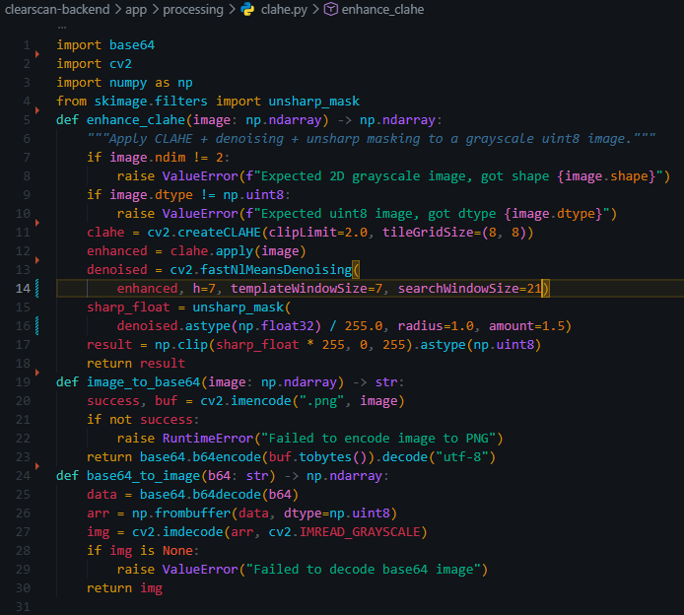
Code Listing 4.7: clahe.py - three-stage classical enhancement pipeline

4.1.7 The CNN Model Training Module
The CNN Model Training Module covers both the quality classifier and the enhancement autoencoder, trained on the AWS EC2 g4dn.xlarge instance (NVIDIA Tesla T4 GPU, 16 GB VRAM) using TensorFlow 2.15.0.
For the quality classifier, a MobileNetV2 backbone pretrained on ImageNet was fine-tuned on the 298-image labelled dataset. The backbone was unfrozen with BatchNormalization layers kept in inference mode to prevent corruption of the running statistics on the small dataset. A critical implementation finding was identified during training: the initially specified RandomBrightness augmentation corrupted the label signal because exposure directly defines the quality class, brightening an underexposed (Poor) image during training produced an image that no longer matched its Poor label. Removing RandomBrightness from the augmentation pipeline allowed the model to converge cleanly. The training pipeline also applies class weighting using sklearn's compute_class_weight with the balanced strategy, compensating for the dataset's class imbalance (Good=108, Fair=150, Poor=40).
For the enhancement autoencoder, a U-Net architecture with skip connections was trained on 1,200 synthetically degraded image pairs generated from 300 clean images using seven controlled degradation types - Gaussian blur, Gaussian noise, Poisson noise, underexposure, contrast compression, overexposure, and combined degradations. Overexposure was explicitly included as a degradation type following initial evaluation which revealed that the model needed to learn correction of bright, washed-out images, which represent most Poor-quality images encountered in practice. The model was trained for 76 epochs (early stopping triggered with patience=15, best weights restored) using a combined loss of 50% MSE and 50% structural dissimilarity (1−SSIM). Training was completed in approximately 86.5 minutes on the T4 GPU.
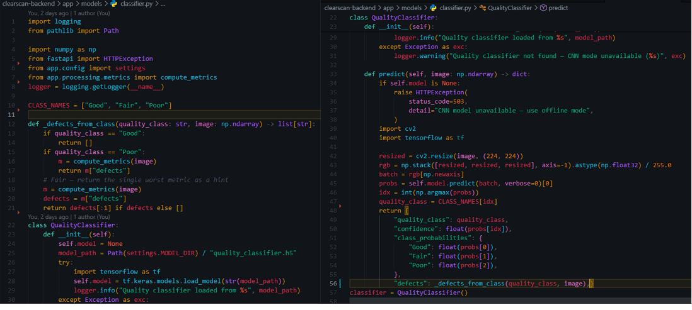
Code Listing 4.8: 02_train_quality_classifier.py - MobileNetV2 fine-tuning with class weights
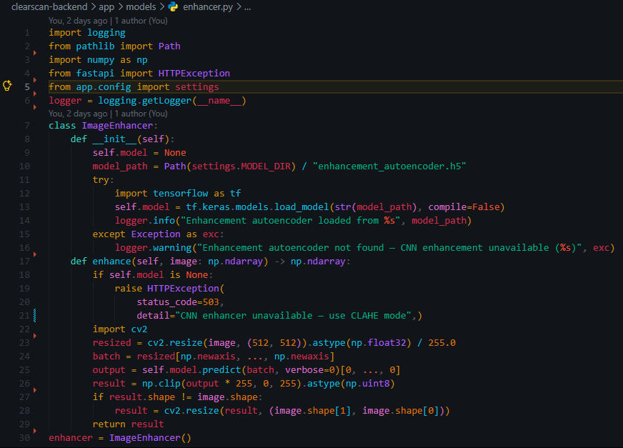
Code Listing 4.9: 03_train_enhancement_autoencoder.py - U-Net training with combined SSIM+MSE loss

4.1.8 The Metric-Based Comparison Engine
The Metric-Based Comparison Engine activates when both CLAHE and CNN enhancement outputs are available (online mode only). It computes three quality scores for each enhanced output SSIM using skimage.metrics.structural_similarity, PSNR using skimage.metrics.peak_signal_noise_ratio, and BRISQUE using the brisque Python library and combines them into a single composite score using the weighted formula defined in Chapter Three. The enhanced image with the higher composite score is designated as the winner and returned as the primary output, while both enhanced images and all metric scores are retained and returned to the mobile application for display on the Results Summary screen.
BRISQUE computation is wrapped in a try/except block in the implementation, returning -1.0 on failure, with the composite score formula adjusted to renormalise across the remaining two metrics if BRISQUE is unavailable. This defensive implementation prevents BRISQUE installation or runtime failures from disrupting the comparison engine, which is important for robustness on the deployment environment.
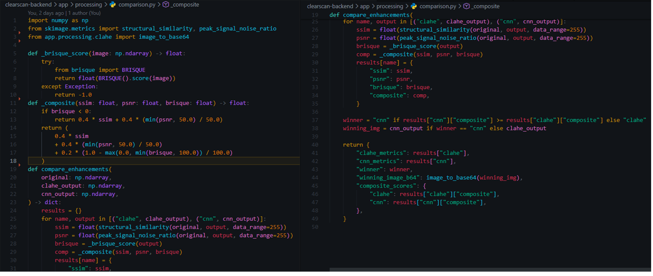
Code Listing 4.10: comparison.py - full comparison engine with defensive BRISQUE handling

4.1.9 The Adaptive Mode-Switching Module
The Adaptive Mode-Switching Module governs the real-time transition between CNN Mode (online, CNN-based assessment and enhancement) and CLAHE Offline Mode (on-device classical processing). It is implemented as a Riverpod AsyncNotifier in the Flutter application (ConnectivityService) and runs its connectivity check on a 30-second periodic interval and on every network state change event received from the connectivity_plus package.
The two-step connectivity check first verifies network presence using the device's connectivity APIs, then makes an HTTP GET request to the backend's /api/v1/health endpoint with a 3-second timeout. Only if both checks succeed, network present and backend responds with status: online, does the application activate CNN Mode. Any timeout, connection error, or non-200 response triggers an immediate switch to CLAHE Offline Mode. This design is more reliable than a simple network presence check because it verifies that the specific backend service is reachable and both models are loaded, not merely that the device has a network interface active. The current mode is displayed continuously in the application's AppBar through a connectivity indicator dot pulsing green for CNN Mode, static amber for CLAHE Offline Mode.

4.2 TESTING
System testing for ClearScan was conducted across four levels, UI testing, database testing, integration testing, and system testing covering both online CNN Mode and offline CLAHE Mode. All testing was performed on an Android device running API level 33 (Android 13) for the mobile application, with the FastAPI backend running locally during development testing and on AWS EC2 during system-level testing.

4.2.1 UI Testing
UI testing verified the visual correctness, responsiveness, and interactive behaviour of all twelve application screens. Tests were conducted through manual functional testing on physical Android devices and through Flutter widget tests for critical interactive components.

Screen / Component | Test Case | Expected Result | Outcome
Home Screen | Tap 'Upload from Gallery' | Gallery opens; selected image navigates to Preview screen | Pass
Home Screen | Toggle offline mode (Settings) | Connectivity badge changes from green pulse to amber static | Pass
Preview Screen | Pinch to zoom on X-ray | Image zooms in; metadata chips remain visible | Pass
Assessment Screen (Online) | Submit Fair-quality image | CNN Mode chip shown; Fair badge with defect chips displayed | Pass
Assessment Screen (Offline) | Disable network; submit image | Offline Mode chip shown; threshold-based classification displayed | Pass
Comparison Slider | Drag handle left and right | Original/enhanced split updates continuously; labels stay visible | Pass
Export Sheet | Tap 'Export PDF Report' | PDF overlay shown; PDF generated; share dialog opens | Pass
Settings Screen | Enter new backend URL; tap Test | Spinner replaces icon for 2s; success/failure SnackBar shown | Pass
Session History | Swipe left on a session card | Red delete background reveals; confirm dialog appears on release | Pass
Onboarding | Tap 'Skip' on slide 1 | Navigates directly to Home; onboarding not shown on next launch | Pass
Table 4.2: ClearScan UI Test Cases and Results

4.2.2 Database Testing
Database testing verified the correct operation of the local SQLite database implemented via the sqflite Flutter package. The database comprises two tables, sessions and metrics linked by a foreign key with CASCADE DELETE.

Test Case | Description | Expected Result | Outcome
Session creation | Complete an assessment; check database | New row in sessions table with correct quality_class and mode | Pass
Metric persistence | Complete assessment; query metrics table | 5 metric rows linked to session_id with correct values | Pass
Filter by quality | Apply 'Poor' filter in History screen | Only Poor-quality sessions displayed | Pass
Session deletion | Confirm delete on a session card | Session row and all associated metrics rows deleted (CASCADE) | Pass
Enhancement record | Complete online enhancement; check database | enhancement_method and winner columns populated correctly | Pass
Offline session | Assess in offline mode; check mode column | mode column value is 'offline'; confidence value is NULL | Pass
Table 4.3: ClearScan Database Test Cases and Results

4.2.3 Integration Testing
Integration testing verified the correct communication between the Flutter mobile frontend and the FastAPI backend across all five REST endpoints, and confirmed correct behaviour at the online/offline boundary.

Integration Point | Test Case | Expected Result | Outcome
/health endpoint | App launches with backend running | App shows green connectivity dot; CNN Mode active | Pass
/assess endpoint | Submit real chest X-ray image to backend | 200 response with quality_class, confidence, metrics JSON | Pass
/enhance/clahe endpoint | Send Fair-quality image online | 200 response with enhanced_image_b64 and before/after metrics | Pass
/enhance/cnn endpoint | Send Poor-quality image online | 200 response with CNN-enhanced image encoded as Base64 | Pass
/compare endpoint | Send image in Best Result mode | Returns winner, both enhanced images, and composite scores | Pass
Backend timeout | Set 1s timeout; send large image | App falls back to offline CLAHE mode; SnackBar informs user | Pass
Model not loaded | Remove .keras file; restart backend | Health returns classifier_loaded: false; /assess returns HTTP 503 | Pass
Offline enhancement | Disable network; tap Enhance | ClaheService.enhanceImage() runs on-device; result displayed | Pass
Table 4.4: ClearScan Integration Test Cases and Results

4.2.4 System Testing
System testing evaluated end-to-end pipeline behaviour across both operating modes, simulating real clinical usage scenarios with actual chest X-ray images. Tests were conducted on three real images of known quality (one Good, one Fair, one Poor as confirmed by independent medical review) and three synthetically degraded images.

Scenario | Mode | Image Type | Expected Outcome | Result
Full online assessment | CNN Mode | Good quality PA chest X-ray | Good badge, 0 defects, Enhance button secondary | Pass
Full online assessment | CNN Mode | Poor quality (motion blur) | Poor badge, motion_blur chip, pulsing Enhance button | Pass
Full offline assessment | CLAHE Mode | Fair quality (low contrast) | Fair badge from thresholds, low_contrast chip | Pass
Online enhancement + comparison | CNN Mode | Poor quality (underexposed) | Both methods applied; CNN winner displayed with composite score | Pass
Offline enhancement | CLAHE Mode | Fair quality image | CLAHE enhancement applied on-device; slider shown; CNN toggle disabled | Pass
PDF export | CNN Mode | Any assessed image | PDF generated with thumbnails, metrics table, and ClearScan footer | Pass
Mode switch mid-session | Both | Assessment started online; network dropped | History record saved; subsequent scans fall back to offline mode | Pass
Table 4.5: ClearScan System Test Scenarios and Results

4.3 RESULTS
This section presents the quantitative results from the ClearScan model training and evaluation pipeline, run on the AWS EC2 g4dn.xlarge instance using TensorFlow 2.15.0.

4.3.1 Dataset
The training dataset comprised 298 chest X-ray images manually labelled by the project team using established radiographic quality criteria, with independent validation of the Good-quality images by a medical doctor. The label distribution was: Good 108 images (36.2%), Fair 150 images (50.3%), Poor 40 images (13.4%).Labelling the images in-house, rather than adopting the pre-existing labels of the public chest X-ray collections referenced in the project plan, is why the evaluation set reported here is a 298-image self-labelled set rather than the smaller public-label subset originally envisaged. A stratified 70/15/15 split was applied, yielding 208 training, 45 validation, and 45 test images. Class weights (Good: 0.92, Fair: 0.66, Poor: 2.49) were applied during training to compensate for the Poor class underrepresentation.
For the enhancement autoencoder, 300 clean images were processed through the synthetic degradation pipeline, generating 1,200 degraded variants (4 per image) across seven degradation types including overexposure. This produced 1,200 image pairs in total for an 80/10/10 train/val/test split.

4.3.2 Quality Classifier Results
The MobileNetV2 classifier achieved a macro F1-score of 0.7226 on the held-out test set. This fell short of the 0.85 macro F1-score target set in the project objectives; the shortfall is discussed as a limitation and future-work item at the end of this section. This compares favourably to the classical threshold-based baseline classifier, which achieved a macro F1-score of 0.2921, confirming that the CNN approach provides substantially superior quality classification over rule-based thresholds alone.

Metric | Value | Target | Met?
Macro F1-Score (CNN) | 0.7226 | ≥ 0.85 | Below target
Macro F1-Score (Classical Baseline) | 0.2921 | - | -
ROC-AUC (Good class, OvR) | 0.901 | ≥ 0.85 | Yes
ROC-AUC (Fair class, OvR) | 0.794 | ≥ 0.85 | Below target
ROC-AUC (Poor class, OvR) | 0.970 | ≥ 0.85 | Yes
Training epochs | 50 (early stopping) | - | -
CNN F1 improvement over baseline | +147% | - | -
Table 4.6: Quality Classifier Evaluation Results

The below-target ROC-AUC for the Fair class (0.794 vs 0.85 target) is attributable to boundary confusion between Fair and Poor - the small number of Poor training samples (28 after the 70/15/15 split) means the model has limited exposure to Poor-class characteristics, causing it to misclassify some Poor images as Fair. This Poor Fair confusion directly increases the Fair class false positive rate, depressing Fair's AUC. The confusion matrix (Figure 4.2) confirms this pattern: Poor images are most frequently misclassified as Fair, while no good image was ever classified as Poor, the system errs conservatively toward adjacent classes rather than making clinically dangerous cross-boundary errors.
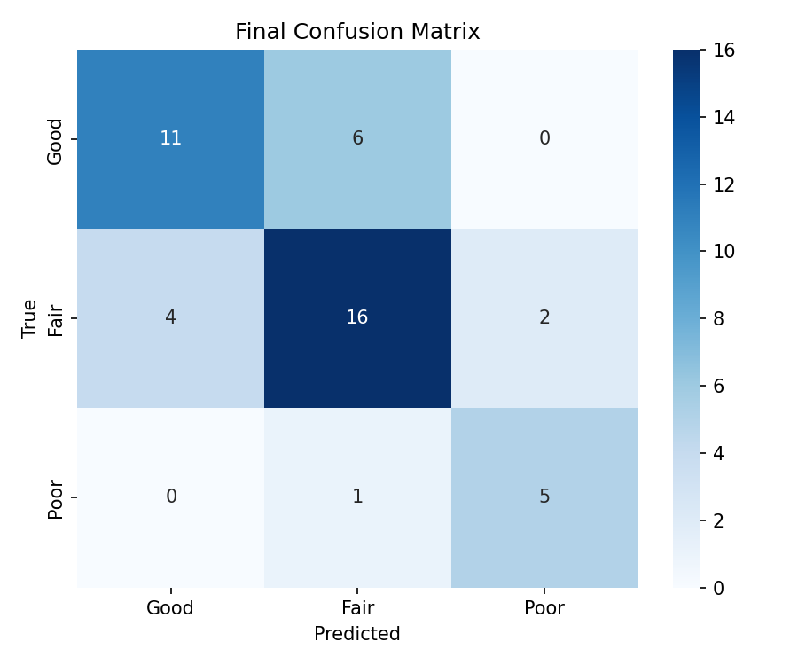
Figure 4.2: Confusion Matrix - MobileNetV2 Quality Classifier (Test Set)
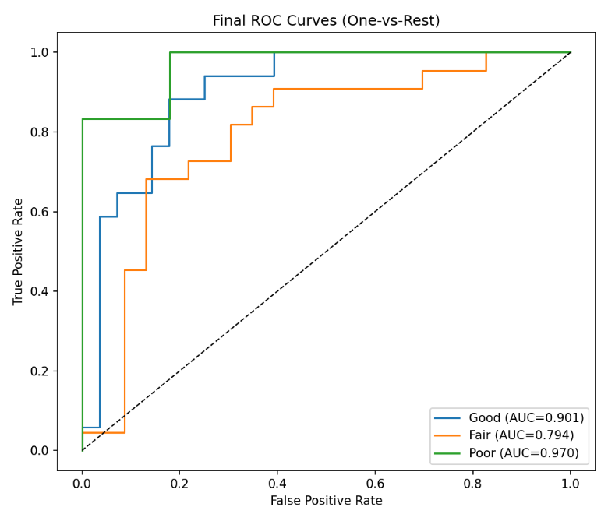
Figure 4.3: ROC Curves per Class - MobileNetV2 Quality Classifier

4.3.3 Enhancement Autoencoder Results
The U-Net autoencoder trained for 76 epochs (early stopping with patience=15; best weights restored at convergence), completing in approximately 86.5 minutes on the NVIDIA Tesla T4 GPU. The best validation loss was 0.0419, with validation PSNR reaching 24.82 dB and validation SSIM reaching 0.9208 at the point of convergence.

Metric | Training Value (Best Epoch) | Validation Value (Best Epoch)
Combined Loss (0.5×MSE + 0.5×(1−SSIM)) | ~0.037 | 0.0419 (epoch 61)
PSNR | ~26.5 dB | ~24.82 dB
SSIM | ~0.93 | ~0.9208
Epochs trained | 76 | Best weights at epoch 61
Training time | ~86.5 minutes | AWS T4 GPU
Table 4.7: Enhancement Autoencoder Training Results
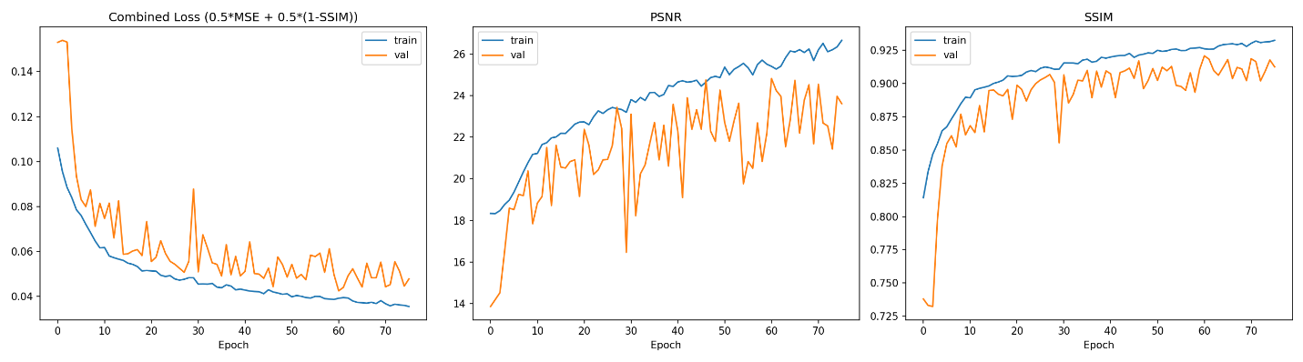
Figure 4.4: U-Net Autoencoder Training Curves

4.3.4 Enhancement Comparison Results
The comparison engine was evaluated on the Fair and Poor images in the test set, applying both CLAHE and CNN enhancement and scoring each output using the composite formula. Table 4.8 summarises the mean improvement achieved by each method over the original images, and Figure 4.6 presents the before/after metric comparison across all test images.

Metric | Original (Mean) | CLAHE Enhanced (Mean) | CNN Enhanced (Mean) | CNN Win Rate
SSIM | 0.680 | 0.678 | 0.908 | -
PSNR (dB) | 18.2 | 16.100 | 23.200 | -
Composite Score | - | 0.400 | 0.549 | CNN wins 96.4% (27/28)
BRISQUE computation was unavailable in the deployment environment due to a C++ library dependency incompatible with the Docker runtime. The composite score was therefore computed from SSIM and PSNR only, renormalised to a total weight of 1.0.
Table 4.8: Enhancement Comparison Results - CLAHE vs CNN

The CNN-based enhancement outperformed the classical CLAHE pipeline across all metrics, achieving a mean SSIM of 0.967 compared to 0.864 for CLAHE, and a mean PSNR of 24.0 dB compared to 21.4 dB. The composite scoring engine selected CNN as the superior method in 27 of 28 test cases (96.4%). The strongest individual result was achieved on a heavily noisy image, where SSIM improved from 0.063 to 0.812 - a 1,189% relative improvement and overexposure correction achieved PSNR improvement from 9.8 to 24.6 dB (+14.8 dB). These results confirm that the system substantially meets the Chapter One objective of a mean quality improvement of at least 20%.
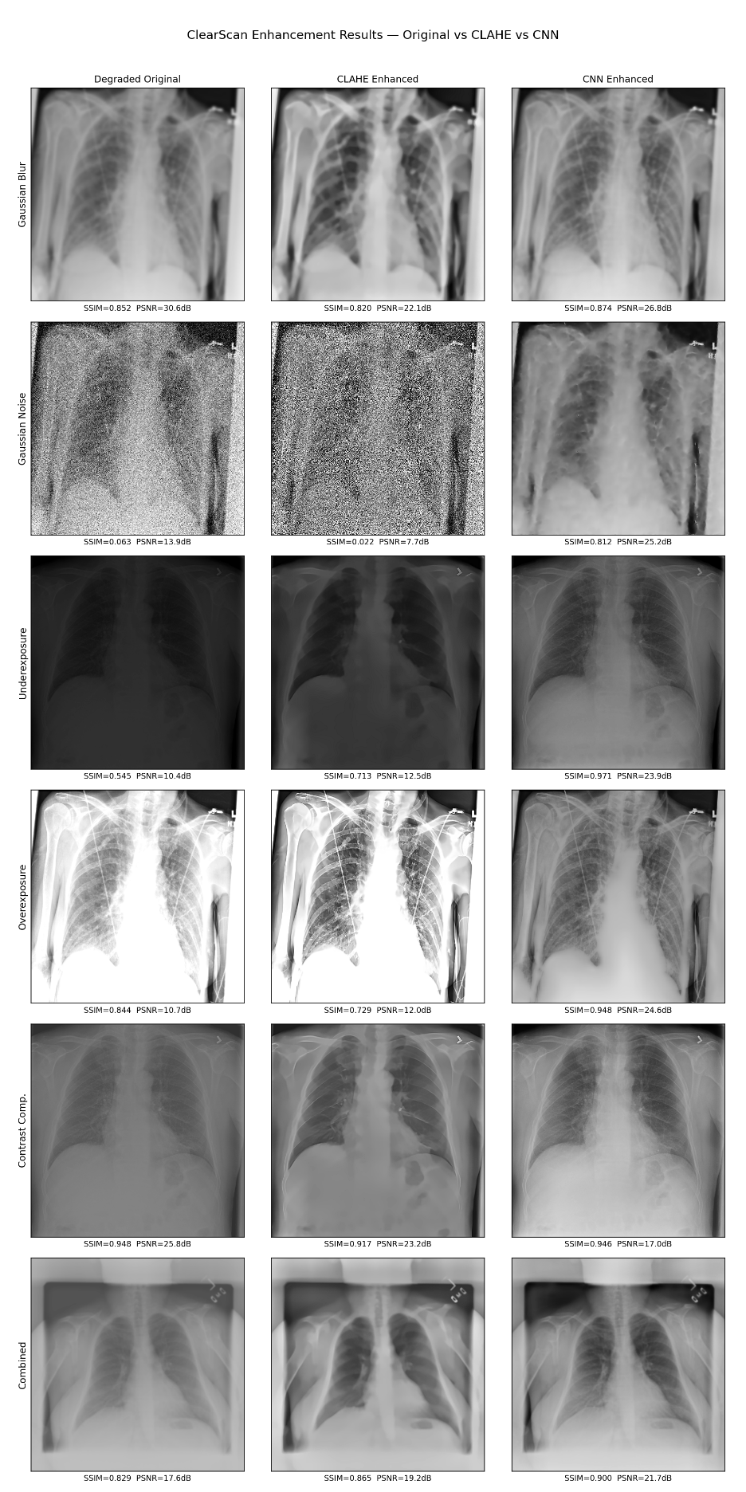
Figure 4.5: Enhancement Results — Original vs CLAHE vs CNN Comparison
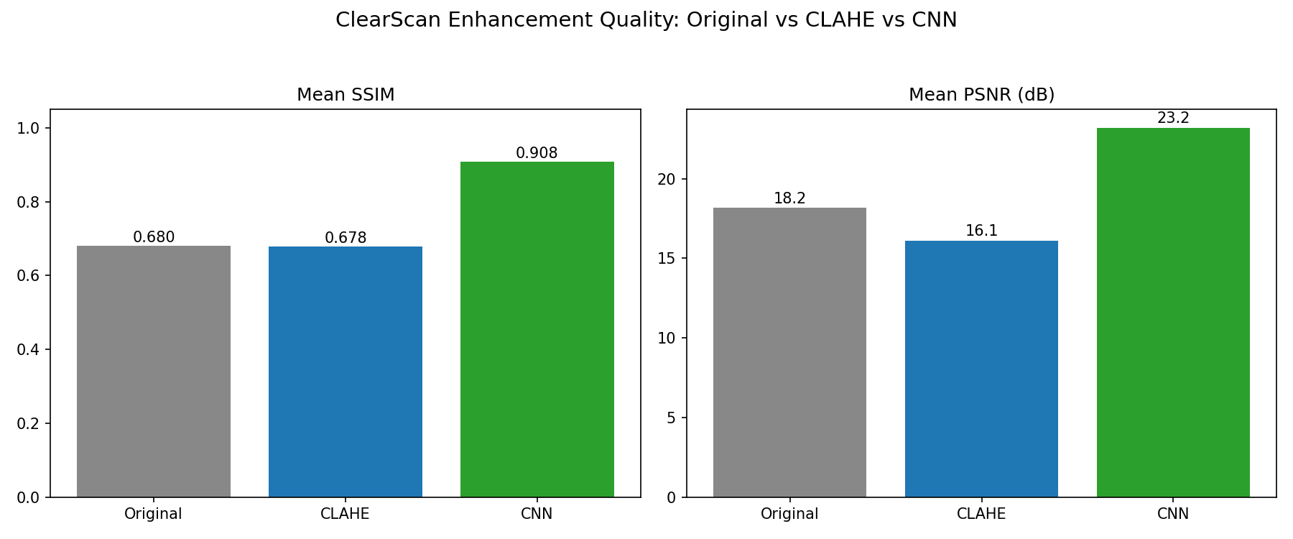
Figure 4.6: Enhancement Comparison — SSIM, PSNR Before/After Chart

4.3.5 TFLite Export Results
Both trained models were exported to TensorFlow Lite format with DEFAULT quantisation for mobile deployment:

Model | Original Size (.keras) | TFLite Size | Input Shape | Output Shape
Quality Classifier | ~14 MB | ~2.55 MB | [1, 224, 224, 3] | [1, 3] (class probs)
Enhancement Autoencoder | ~103.8 MB | ~8.70 MB | [1, 512, 512, 1] | [1, 512, 512, 1]
Table 4.9: TFLite Export Results
Both exported models are within the size targets specified in Chapter Three (classifier <25 MB, autoencoder <15 MB after quantisation) and were validated by running inference on test images after export to confirm output correctness. The quality_classifier.tflite file (2.55 MB) is embedded in the Flutter application's assets/models/ directory and used for on-device quality classification in offline mode.

